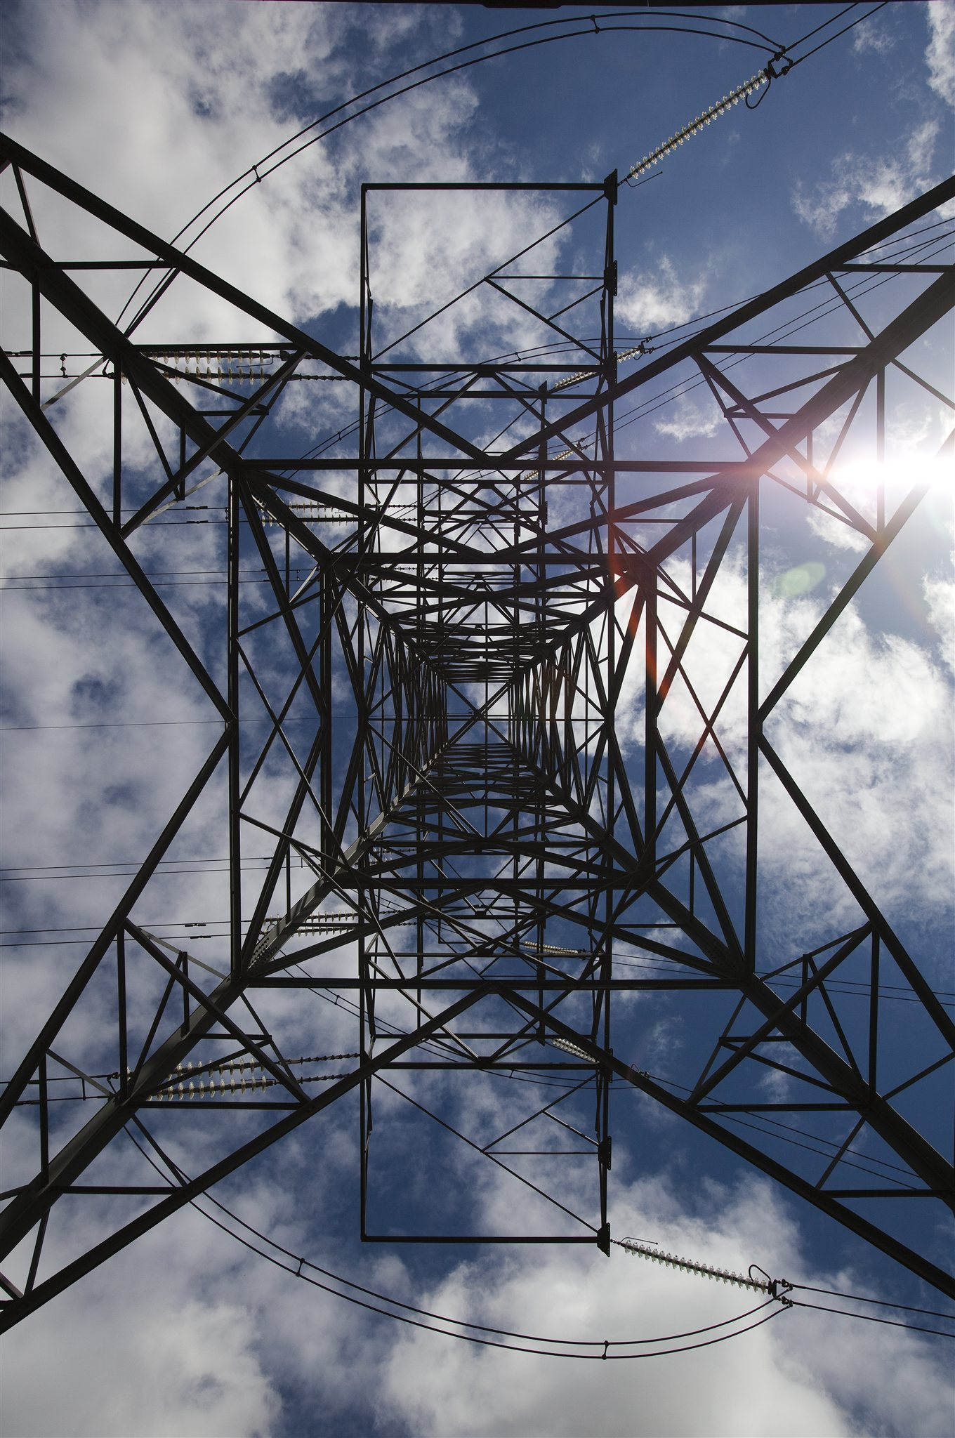

Charging for Investment Ahead of TEC

Guidance Document

October 2017 Version 2.0

Contents

1. Purpose of the Document 3
2. Background 3
3. Recovery of investment costs which become inefficient 4
4. Provision of Backfeed 8
5. Predictability of the Charge 11
Appendix A – Example Charge for investment costs which become inefficient 12
Appendix B – Example Charge for Provision of Backfeed 14

- Purpose of the Document
  - This guidance document sets out how National Grid will apply charges to parties when they make a request which results in the transmission investments under their connection agreement being made earlier than would otherwise have been the case.
- Background
  - Where a customer requests a connection to the transmission system, the transmission owner seeks to plan and carry out all the works necessary for that connection in order to economically and efficiently meet the agreed connection date. The completion date for the transmission works is generally planned to be the date of both connection to, and the exercise of the right to use, the transmission system, at which stage connection charges and Transmission Network Use of System charges (TNUoS) (as appropriate) would be payable. TNUoS is the mechanism by which the costs of investment in transmission (other than those assets classed as connection assets or one off works) are recovered.

  - Where, as a result of a customer request, investment in the transmission system takes place earlier than would otherwise have been required, it may (as detailed in this guidance document) result in an “other charge” under Connection Use of System Code (CUSC) Paragraph 14.4, specifically in the case of Investment Ahead of TEC the following are the relevant principles;

    - Where a cost cannot be capitalised into either a connection or infrastructure asset, typically a revenue cost.
    - Where a non-standard incremental cost is incurred as a result of a User's request, irrespective of whether the cost can be capitalised.

  - There are two cases where a charge may be applicable:

    - Where a customer makes a change to the connection date within its connection agreement which results in the timing of network investment becoming inefficient.
To change a connection date customers are required to submit a modification application. Any charges associated with accommodating the requested change will be outlined in the resulting modification offer. The relevant Transmission Owner (TO) will consider the efficient programme for the new connection date as part of that modification and the extent to which the current programme and expenditure differs from that. Charges will apply where either the otherwise efficient programme will be delivered unnecessarily earlier or the TO will incur additional cost above the efficient programme. Whilst a customer can request changes at any point in a programme it should be recognised that any charges, especially those related to transmission investment, are likely to be lower if we are informed of the change as soon as possible.

    - Where a generator requests a “Backfeed” connection to the National Electricity Transmission System (NETS) the provision of which requires acceleration of transmission investment.
“Backfeed” is a term used by generators where a transmission connection is required to enable a demand supply, commonly to allow for either construction or commissioning of a power station, before the generator wishes to exercise its right to use the transmission system. Whilst, generally, such a backfeed would only be required for a short period ahead of generation commencing, and so with no impact on TO construction programmes, some generators have requested backfeed two to three years ahead of when the power station intends to begin generating. The relevant TO will consider what the efficient programme would be to deliver the connection date in the normal way. Charges will apply where either an earlier programme is required or the TO will incur additional cost above the efficient programme to provide the transmission assets that enable early connection for the sole purpose of backfeed. These charges will be detailed in the offer of connection.

- Recovery of transmission investment costs which become inefficient
  - Charges associated with those transmission investment costs which become inefficient are made up of two elements; recovery of financing costs and recovery of incremental costs incurred as a consequence of the change requested by the customer. These charges will be included in the Bilateral Connection Agreement (BCA) as a One-off Charge (termed as a “Transmission Charge” where paid over a period). An example of how they are applied is included in Appendix A.

  - Financing Costs

      - This cost is applied to the construction costs of the transmission investment that is made earlier than would otherwise have been the case.

      - The relevant TO will consider the efficient programme for the new connection date and the extent to which the current programme differs from that. If the programme would have been the same regardless of the revised connection date, no

      - financing costs will be incurred.

      - If the programme is different and transmission investment has taken place or been contractually committed to these construction costs will be established and the financing cost will be applied to them.

      - The transmission investment relevant for this charge will be Enabling Works. These are defined in the CUSC and listed for a specific project in Appendix H of the relevant construction agreement.

      - Construction costs will include any investment which would form part of the final capital value of the scheme e.g. it will include such items as design, consents, project management, engineering costs, etc.

      - Where a component of the Enabling Works is provided solely for one customer’s connection, the total construction costs of that component will be used to calculate the charge.

      - For components of the Enabling Works which are shared with other parties, the construction costs of such components that will be used to calculate the charge will be identified using following criteria: -
    - If shared Enabling Works would have been built to the original programme irrespective of a customer’s request (e.g. due to the need to meet agreed connection dates for other customers) then no financing cost element is due for those works.
    - Where shared assets would have been built later if the revised date had been known at the start of the project, then the appropriate construction costs will be apportioned based on the benefitting TEC of all concerned projects.

      - Where, following a request to delay, it is practicable, economic and efficient to suspend investment, we will establish construction costs of the transmission investment at the time of suspension and apply the financing cost to calculate the charge.

      - In determining whether it is practicable, economic and efficient to suspend investment, a number of factors will be taken into account by the relevant TO. These will include, but are not limited to:

    - The relative costs of de/remobilisation compared to completion.
    - The ability of the transmission owner to utilise resource (or not as the case may be) on other projects.
    - The availability of transmission outages.
    - The completion of a sensible stage in the construction programme to ensure the system is both safe and secure for the duration of the suspension.

      - If however, following a request to delay, it is determined that the most practicable, economic and efficient action is for the Transmission Owner to continue to the original construction programme, we will calculate the financing cost using the final construction costs of the scheme.

      - Once the appropriate construction costs are known they will be set as the Gross Asset Value. The annual financing cost will be calculated as: -

Annual Charge = R (GAV)

Where:

GAV = Gross Asset Value

R = rate of return (6%)

      - The period of the charge for financing costs will be based on the difference between the TNUoS charging year of the original and revised connection dates. That is, a change of connection date to within the same charging year will not incur a financing cost charge.

  - Incremental Costs

      - Where incremental costs are incurred by the relevant Transmission Owner as a consequence of the change requested by the customer, these will be treated as one-off works and charged as a One-off Charge in the usual way as defined in CUSC Paragraph 14.4.

      - Examples of such incremental costs would be expenditure related to as de-mobilisation/re-mobilisation, additional consents, re-working engineering, etc. This charge would also apply to site specific maintenance costs associated with part built assets.

  - Timing and Period of Charge

      - The financing cost component will be considered a Transmission Charge as it is a one-off charge being paid over a longer period. It will be payable in monthly instalments from the original date of connection to 31 March in the financial year prior to that in which TEC is applicable, that is, when the generator starts paying generation TNUoS.

      - The incremental costs will be a one-off charge payable upon completion of the works. This element of charge may be deferred by agreement but will then incur interest as detailed in CUSC Section 14.

      - The specific details of the charge and the payment timings will be set out in the relevant connection agreement when varied.

- Provision of Backfeed

  - Charges associated with any request for backfeed are made up of two elements; recovery of financing costs and recovery of incremental costs incurred to facilitate the customer request. These charges will be included in the Bilateral Connection Agreement (BCA) as a One-off Charge. An example of how they are applied is included in Appendix B

  - Backfeed Financing Costs

      - This cost is related to the transmission investment that is made earlier than would otherwise have been the case.

      - The relevant TO will consider what the efficient programme would be for the required connection

      - date. If this programme would be the same
regardless of the request for backfeed, no financing costs
      - will be incurred.

      - Charges will apply were the TO will be required to deviate from that programme to provide the transmission assets which enable early connection for the sole purpose of backfeed. These construction costs will be established and the financing cost will be applied to them.

      - The transmission investment relevant for this charge will be Enabling Works. These are defined in the CUSC and listed for a specific project in Appendix H of the relevant construction agreement.

      - Construction costs will include any investment which would form part of the final capital value of the scheme e.g. it will include such items as design, consents, project management, engineering costs, etc.

      - Where a component of the Enabling Works is provided solely for one customer’s connection, the total construction costs of that component will be used to calculate the charge.

      - For components of the Enabling Works which are shared with other parties, the construction costs of such components that will be used to calculate the charge will be identified using following criteria: -
    - If shared Enabling Works would have been built to the original programme irrespective of a customer’s request (e.g. due to the need to meet agreed connection dates for other customers) then no financing cost element is due for those works.
    - Where shared assets would have been built later if the revised date had been known at the start of the project, then the appropriate construction costs will be apportioned based on the benefitting TEC of all concerned projects.

      - When there is a request from a customer for a backfeed connection we will calculate the financing cost using the construction costs of the transmission investment required to provide the import supply requested for backfeed.

      - If it is economic and efficient to build other assets at the same time, for example if a new GIS substation or significant extension is required and it is more economic and efficient to build all those assets required for the customers connection, then the construction costs for all assets provided will be used.

      - Once the appropriate construction costs are known they will be set as the Gross Asset Value. The annual financing cost will be calculated as follows: -

Annual Charge_{n} = D (GAV_{n}) + R (NAV_{n})

Where:

GAV_{n} = GAV for year n.
NAV_{n} = Net Asset Value and is the mid-year value for year n based on GAV_{n}
n = the year to which charge relates within the Depreciation Period
D = Depreciation rate 2.5% (equal to 1/40 of GAV)

R = rate of return (6%)

      - Only where the TO is required to deviate from the efficient programme the assessment of financing costs will be based on the difference between the TNUoS charging year of the requested backfeed and connection date.

  - Backfeed Incremental Costs

      - Where incremental costs are incurred by the relevant Transmission Owner to facilitate a request for backfeed by the customer, these will be treated as one-off works and charged as a One-off Charge in the usual way as defined in CUSC Paragraph 14.4.

      - Examples of such incremental costs would be expenditure related to temporary works used to provide backfeed which are later removed or replaced by final connection works.

  - Period of Charge

      - The financing cost component will be considered a Transmission Charge as it is a one-off charge being paid over a longer period. It will be payable in monthly instalments from the date backfeed is provided to 31 March in the financial year prior to that in which TEC is applicable, that is, when the generator starts paying generation TNUoS.

      - The incremental costs will be a one-off charge payable upon completion of the works. This element of charge may be deferred by agreement but will then incur interest as detailed in CUSC Section 14.

      - The specific details of the charge and the payment timings will be set out in the relevant connection agreement when varied.

- Predictability of the Charge
  - Appendix H of a construction agreement lists the Enabling Works applicable to a particular connection. Cost profile information for these Enabling Works will be issued with the six monthly security updates. You will be able to use these profiles together with this guidance to help make an estimate of the GAV and financing costs element of a charge which may be levied in relation to a request to change the connection date although you will appreciate these will only give you an indication as we will use the actual costs to calculate any charge.

  - The values of any incremental costs are site specific and dependant on the circumstances at the time a change in connection date is requested. These are additional costs above and beyond the scope of works initially planned to meet the original connection date. The full details of these costs will be provided with the modification offer. For project specific information your Connection Contract Manager can provide assistance.

Appendix A – Example Charge for investment costs which become inefficient
Generator A requires a new substation and connection to existing substation C. Generator B is connecting at a location between A and C. As a result substation A and line A-B are solely required for generator A. Works at Substation B and the line from B-C will be shared with Generator B.

Generator A has requested a TEC of 1,000MW for 1/4/2020
Generator B has requested a TEC of 1,000MW for 1/4/2019

Appendix H shows the following Enabling Works associated with Generator A’s offer:

- Construction of New Substation A at point of connection
- Construction of New Overhead line from Substation A to Substation B
- Construction of New Substation B and Overhead Line to Substation C

Separately we provide the following information:

Enabling Work 1: GAV = £12m Construction period 1/4/2017-1/4/2020
Enabling Work 2: GAV = £120m Construction period 1/4/2017-1/4/2020
Enabling Work 3: GAV = £150m Construction period 1/4/2016-1/4/2019

For the purposes of this example it is assumed that investment is linear.

Generator A makes an application in Autumn 2017 to delay their connection date to 1/4/2021.
In conjunction with the Transmission Owner an assessment is made which demonstrates we can suspend work on Enabling Works 1 and 2 at the end of 2017/18 for one year and then recommence at the start of 2019/2020.
However we will incur additional costs for de-mobilisation and re-mobilisation of £0.5m.
We will continue with Enabling Works 3 as it is required for Generator B and would have constructed to the same programme even if we had known of Generator A’s new date at the start, therefore, there is no charge associated with these works.

The following calculation will be applicable:

Financing Cost

As we are able to suspend the work on Enabling Work 1 and 2 at the end of 2018, meaning that these works are 1/3 complete, the following GAV_{d} are appropriate:

Enabling Work 1: GAV = £12m x 1/3 = £4m
Enabling Work 2: GAV = £120m x 1/3 = £40m
Enabling Work 3: GAV = £0

Total GAV = £44m

The Annual Charge is calculated as = R(GAV)
= 0.06*44
= £2.64m

This will be charged as a monthly charge of £220k from the original connection date of 1/4/2020 to the new connection date of 1/4/2021.

Incremental Cost

A One-off charge = Costs x (1+R)
= 500 x 1.06
= £530k

Appendix B – Example Charge for Provision of Backfeed
Generator X requires a new substation and connection to existing substation Y.

Generator X has requested a TEC of 1,000MW for 1/4/2020.

Appendix H shows the following Enabling Works associated with a connection offer

- Construction of New Substation X at point of connection connected to an existing circuit.

To meet the Generators requirement we would need to make the following investment:

Enabling Work 1: GAV = £12m Construction period 1/4/2017-1/4/2020

For the purposes of this example it is assumed that investment is linear.

Generator X requests that a supply for backfeed is made available on 1/4/2019.
In conjunction with the Transmission Owner an assessment is made which demonstrates the construction of Enabling Work 1 is required in full to allow for backfeed.

The following calculation will be applicable:

Financing Cost

To meet the Generators requirement, the programme would now be:

Enabling Work 1: GAV = £12m Construction period 1/4/2016-1/4/2019

This means that GAV for Generator X will be £12m

The associated mid-year NAV for year one is 12(1-(0.025/2)) = £11.85m

The Annual Charge is calculated as = D(GAV₁) + R(NAV₁)
= 0.025*12 + 0.06*11.85
= £1.011m

This will be charged as a monthly charge of £84k from the backfeed date of 1/4/2019 to the connection date of 1/4/2020.

Incremental Cost

There is no incremental cost associated with this backfeed.

