## 

**National_Grid_logo_blue**

Network Options Assessment for Interconnectors

Interconnectors Welfare Benefit Assessment Methodology for ITPR Year 2

May 2016

J6ne 2015

|  |  |
| --- | --- |
| **Version** | **DRAFT 2.0** |
| **Date** | **25th May** |

**About this document**

This document contains National Grid’s Network Options Assessment (NOA) methodology for assessment of interconnectors established under NGET Licence, Licence Condition C27 in respect of the financial year 2016/17. It covers the methodology on which NGET in its role as SO will base the second NOA for Interconnectors report which will be published by 31 January 2017. National Grid’s experience and stakeholder feedback has informed the development of this methodology. The methodology statement has been revised for the second NOA for Interconnectors and will continue to be on an enduring basis as required by Licence Condition C27.

Contents

[1. Overview 3](#_Toc452034576)

[1.1. Structure of the Document 3](#_Toc452034577)

[2. Criteria for selection of interconnection capacity 4](#_Toc452034578)

[3. CAPEX estimation for interconnection capacity 6](#_Toc452034579)

[4. Components of Welfare Benefits of Interconnectors 7](#_Toc452034580)

[4.1. Introduction 7](#_Toc452034581)

[4.2. Social and Economic Welfare 7](#_Toc452034582)

[4.3. Effects on Interconnected Markets 7](#_Toc452034583)

[5. Models employed by the System Operator 10](#_Toc452034584)

[5.1. Electricity Scenario Illustrator 3 (ELSI3) 10](#_Toc452034585)

[5.2. BID3 10](#_Toc452034586)

[6. Interconnection Assessment Methodology 12](#_Toc452034587)

[6.1. Optimisation of GB-Europe Interconnection Process 12](#_Toc452034588)

[6.2. Modelling inputs 13](#_Toc452034589)

[6.3. Copperplate model 15](#_Toc452034590)

[6.4. Market Modelling 16](#_Toc452034591)

[7. Process Output 17](#_Toc452034592)

## Overview

1.1 The purpose of the Network Options Assessment (NOA) is to facilitate the development of an efficient, coordinated and economical system of electricity transmission consistent with the National Electricity Transmission System Security and Quality of Supply Standard (NETS SQSS) and the development of efficient interconnector capacity. Interconnectors with other European markets will increasingly play an important role to achieve this goal.

1.2 This document provides an overview of the aims of the NOA with respect to interconnectors and details the methodology which the System Operator (SO) will adopt for the analysis and publication of the second NOA report (to be published by 31st January 2017). The SO shall undertake a more detailed, expansive analysis for NOA for Interconnector’s second iteration. Furthermore, since the publication of the first methodology, the SO has undertaken procurement of a new Pan European Market Model, BID3. This enhances the capabilities of the SO, but also creates risk associated with the introduction of a new tool. The uncertainty created by this risk and an approach to mitigate this is reflected in the document.

### Structure of the Document

1.3 This document consists of the 5 chapters listed below:

Criteria for selection of interconnection capacity

This chapter contains a justification of the factors to be considered in the determining whether additional capacity would be beneficial.

Cost estimation for interconnection capacity

The costs associated with an interconnector and how these will be forecast is outlined.

Components of Welfare Benefits of Interconnectors

The concept of Social Economic Welfare in relation to interconnection, and the components of this value, is explained.

Models employed by the System Operator

A description of the SO’s current market modelling capabilities is given

Interconnection Assessment Methodology

A description of the method by which the SO proposes to meet the aims of NOA in relation to optimal interconnection capacity is provided.

## Criteria for selection of interconnection capacity

2.1 There are multiple criteria that could be considered when evaluating interconnector projects. The foremost are Social Economic Welfare, described in detail in section 4, capital costs and impact on constraint costs.

2.2 The impact on constraint costs is associated with the connection location of an interconnector. Changes in the total System Operator expenditure spent on balancing the system are then highly dependent on flows local to that connection point. They can thus only be quantified for specific projects- that is, a particular capacity connecting within a particular network area. To give a general picture on which network areas are best able to accommodate new interconnectors (or will be in the future following reinforcements) the ETYS and NOA reports provide information on the current state and ongoing development of the onshore network. This is done through the quantification of boundary limitations, and the presentation of recommended options for reinforcement of the grid. This is intrinsically linked to the increasing presence and geographical spread of interconnection in the UK- as further interconnectors apply to connect to NGET, these will in turn place further (forecast) strain on boundaries and potentially trigger investment in reinforcements (if the NOA process determines that to be the most economical and efficient course of action). This methodology thus prioritises providing a market based view of optimal interconnection. As the market responds to this and other intelligence with potential projects, the FES view of interconnection will change or remain the same accordingly; this will drive the ETYS view of necessary reinforcements in future years.

2.3 Two factors that will be analysed and have some accompanying commentary in the NOA report are changes in carbon emissions and use of Renewable Energy Sources (RES). These indicators are intended to aid understanding of interconnection’s potential contribution or detriment to meeting GBs climate change goals. They will not be used to optimise the interconnection presented. This is due to the complexity of combining Carbon/RES estimates with welfare and cost, especially where modelled welfare is already influenced by such factors through RES incentives and the European Trading System capping carbon emissions.

- Carbon costs: both modelling facilities allow for the extraction of total carbon emissions resulting from particular market states under different scenarios, thus the carbon savings or increases associated with various levels of interconnection can be presented with commentary. The interaction of emissions and welfare with the European Trading System in carbon may reduce the apparent impact of interconnection directly on emissions; further analysis and commentary in the report should explain this effect.

- RES integration: both modelling facilities allow for the investigation of impact of interconnection on renewable generation. This can be reviewed through investigating the reduction or increase in renewable generation curtailment driven by the optimal level of interconnection being in place in future years, rather than the currently forecast level.

2.4 There are further benefits and costs that could be considered, which are briefly outlined below; they are outside the scope of this methodology, but worthy of mention:

- Environmental/social costs: In any large scale construction project, the local environment almost inevitably suffers damage. This affects local stakeholders, as well as disruption associate with the construction (traffic, noise etc.). The severity varies with the site chosen and the construction methods used. These are not considered here- they are more relevant to the choice of sites for individual projects.

- Social benefits: Depending upon the procurement for the construction, the project may offer a boon to the local economy- this again is a project specific benefit, so is not estimated in this work.

- Ancillary service benefits: A major consideration is the ability of interconnectors to provide services which enhance system operability. This could potentially benefit both the interconnector owner, with additional income streams, and the consumer, by increasing system security or lowering the cost of providing system security. This is evaluated on a project-by-project basis as part of the Cap and Floor mechanism, and will also be dealt with elsewhere in the NOA report, so again is excluded here. More information on ancillary service provision, and interconnectors’ potential contribution to this, is available in the System Operability Framework (SOF).

2.5 SEW and CAPEX are the most significant criteria, in addition to being reasonably straightforward to quantify, so will be used as the determinants of capacity fitness (that is, whether an increase in capacity is beneficial).

## CAPEX estimation for interconnection capacity

3.1 The cost of building interconnection capacity varies significantly between different projects - key drivers are convertor technology, cable length and capacity of cable. Estimating costs for generic interconnectors between European markets and GB is therefore problematic - fortunately, exercises of a similar nature has been undertaken by various industry bodies to allow the generation of ‘Standard Costs’. These are generic values that can be applied to estimate the cost of generic projects. A recent report by ACER [1] provides sufficient granularity to differentiate between standard costs of connection to different markets. Taking these in conjunction with engagement with interconnector developers will allow the development of a robust set of standard cost ranges of the form shown in the table below:

*Table 1 Example standard costs*

|  |  |  |  |  |
| --- | --- | --- | --- | --- |
| Connecting market | Standard cable cost per km of route for 500MW capacity | Standard convertor station cost (both stations) per MW capacity | Other costs | Description of other costs |
| Iceland | £x-£y | £x-£y | £x-£y |  |
| Norway | £x-£y | £x-£y | £x-£y |  |
| Denmark | £x-£y | £x-£y | £x-£y |  |
| Germany | £x-£y | £x-£y | £x-£y |  |
| The Netherlands | £x-£y | £x-£y | £x-£y |  |
| Belgium | £x-£y | £x-£y | £x-£y |  |
| France | £x-£y | £x-£y | £x-£y |  |
| Spain | £x-£y | £x-£y | £x-£y |  |
| Irish SEM (IE & NI) | £x-£y | £x-£y | £x-£y |  |

The table can then be used to generate a generic minimum, mean and maximum cost per MW capacity for each market.

## Components of Welfare Benefits of Interconnectors

### Introduction

4.1 This section outlines the definition of Social Economic Welfare. The purpose of this section is to give the theoretical background of assessing the impact of connected importing and exporting markets on consumers, producers and interconnectors triggered by an interconnector.

### Social and Economic Welfare

4.2 Social and Economic Welfare (SEW) is a common indicator used in cost benefit analysis of projects of public interest. It captures the overall benefit, in monetary terms, to society from a given course of action. It is important to understand it is an aggregate of different parties’ benefits - so some groups within society may lose money as a result of the option taken. The society considered may be a single nation, GB, or the wider European society, in which case the benefits to European consumers and producers would be a part of the calculation. For the case of GB interconnectors, it is most informative to show both GB and Europe wide SEW values, and the components which make up each.

4.3 SEW benefits of an interconnector includes the following three components:

* 1. Consumer surplus, derived as an impact of market prices borne by the electricity consumers
  2. Producer surplus, derived as an the impact of market prices borne by the electricity producers
  3. Interconnector revenue or congestion rents, derived as the impact on revenues of interconnectors between different markets.

4.4 Interconnectors could help to provide ancillary services (including black start capability, frequency response or reserve response), facilitate deployment of renewables, reduction in carbon emissions and displace network reinforcements. Interconnectors also provide benefits of being connected to more networks giving access to a more diverse range of generation which could lead to reduction in carbon emissions.

### Effects on Interconnected Markets

4.5 Power flows between two connected markets is driven by price differentials. Figure 1 shows the effects of such price differentials for two markets, A and B with variable prices over time. When the price is higher in market A, power will be transferred from B to A. When the price in A is lower than in B power will be transferred from A to B.

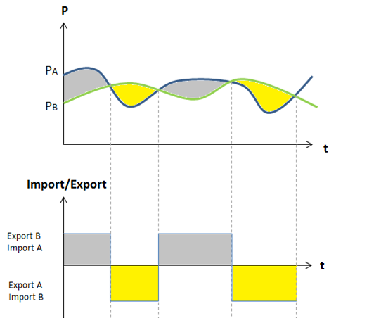

*Figure 1 Price difference as import and export driver*

4.6 Figure 2 shows the impact of an interconnector (+IC) linking two markets on consumer (Demand D) and producer (Supply S) costs. When two competitive markets with different price profiles are interconnected, price arbitrage drives power flow from the low price market (B) to the high price market (A). Consumers in market A are likely to gain (a + b) as they benefit from access to cheaper power. Consumers in market B are likely to lose (d). Generators in market A, now able to compete with generators in B, are likely to be forced by competitive pressures to reduce their costs, which might lead to a reduction in their profits (a). Producers in market B are likely to gain (d + e). Interconnector revenue (c) is derived from the remaining price difference.

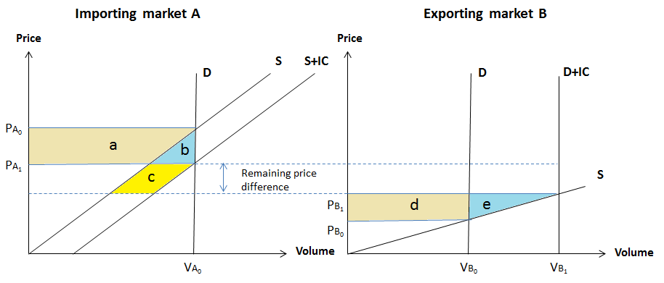

*Figure 2 Consumer and Producer Surplus of connected markets*

4.6 With greater interconnection the price difference between markets will decrease thus the revenue of the interconnector will be reduced as well. This phenomenon is known as ‘cannibalisation’. There is an optimal level of interconnection between any two markets because price differential reduces as capacity increases, i.e. area c in Figure 2 shrinks.

4.7 Forecasts of all components of SEW benefits will be key drivers to ascertain the optimum level of interconnection between GB and other European member states. The outputs of this process will include monetised impacts on GB consumers, producers and considered interconnectors.

4.8 The Global SEW is the sum of the welfare of 5 parties (GB & Europe consumers, GB & Europe producers, Interconnector owners). The British SEW is the sum of the welfare of all British parties. Using the ownership structure of existing GB interconnectors, assuming 50% of interconnector owner welfare remains in the GB economy is plausible.

## Models employed by the System Operator

### Electricity Scenario Illustrator 3 (ELSI3)

5.1 The market modelling tool that has been used until now by National Grid is called ELSI; it is used to forecast the constraint costs for different network states and scenarios. The newest iteration, ELSI3, is used for modelling European markets in addition to GB. It is an open source Excel based tool, developed in-house and made available to stakeholders to conduct their own constraint forecasting. The high-level assumptions and inputs used in ELSI3 are outlined in Table 1.

*Table 2 Assumptions and input data for ELSI*

|  |  |  |
| --- | --- | --- |
| Input Data | Current Source | Description |
| Fuel price forecasts | FES | 20 year forecast, varies by scenario |
| CO2 forecasts | Baringa | 20 year forecast |
| Plant efficiencies and seasonal availabilities | Historical data |  |
| Plant bid and offer prices | Historical data | Related to SRMC costs |
| Forecast system marginal prices for non-modelled overseas markets | Baringa | 20 year forecast, varies by scenario and market |
| Wind data | Pöyry (historical) | Wind load factors for various zones around GB |
| Demand data | FES | MW annual peak and zonal distribution |
| Load duration curve | Historical data | 2012/13 outturn data converted into ELSI periods |
| Maintenance outage patterns | Historical data | Maintenance outage durations by boundary |

5.2 The model simulates 4 periods per day for 365 days per year (=1460 periods per year) and is set to simulate 20 years into the future. The primary output for the interconnectors’ welfare benefit assessment process, particularly measured as consumer surplus, is the annual System Marginal Price (SMP) forecast.

5.3 ELSI3 is a zonal fuel type model. A distinction between generators of the same fuel type in the same zone is not possible. Therefore, output data, e.g. volumes of output (and thus costs), cannot necessarily be attributed to specific generators.

### BID3

5.4 BID3 was procured to add market modelling capability to the System Operator, above and beyond that available in ELSI. The tool will be delivered in the summer of 2016.

5.5 BID3 is a Pan European Market Model created by Pöyry. It offers improvements in accuracy and scope of modelling, featuring: working models of all ENTSOE countries; hourly time resolution; optimisation of plant operation over multiple periods (particularly with respect to thermal and hydro plants which have constraints on operating patterns); easy to use outputting populated with key indices such as congestion rent and consumer welfare; and several further modules for economic analysis not directly applicable to the interconnection issue.

5.6 In the summer of 2016, further development of the tool and benchmarking with ELSI will build confidence and skill in deploying the model; this will allow its use in the autumn to perform key NOA work.

5.7 The introduction of a new tool to the NOA process creates risk - inexperience with the software could lead to incorrect setup of inputs, or misunderstanding of the results. While this risk is to be mitigated through benchmarking and extensive training, a further measure is ensuring the NOA process is compatible with ELSI3, such that results can be checked with a software package that has been used previously and is trusted.

## **Interconnection Assessment Methodology**

### Optimisation of GB-Europe Interconnection Process

*Figure 3 Process summary*

6.1 The optimisation of future interconnection capacities is a multivariable search, maximising the SEW-less-CAPEX value. The decision variables are the total MW capacities (the sum of all interconnector transfer capacities) between GB and 9 adjacent markets, for both importing and exporting. The countries in question are: Iceland; Norway; Denmark; Germany; The Netherlands; Belgium; France; Spain; and Ireland (which includes the Republic of Ireland and Northern Ireland). The number of variables makes an exhaustive search within a useful timeframe infeasible - a search strategy must therefore be defined.

6.2 Not included in the search is the level of interconnection between the European markets. These levels will be fixed throughout per scenario (though could vary across future years) and initially defined by the SO based on ENTSO-E and NG forecasts.

6.3 To guide the search, upper limits to potential power transfers between markets is found using a copper plate network - this simulates flows between markets under the hypothetical situation of no physical limitations on energy exchange. Ignoring the multiple, complex physical problems that make long distance power transmission difficult and uneconomical means the flows found are usually much higher than practically possible. The flows between the markets that would occur under these conditions are then analysed to find a maximum necessary capacity size. This informs the search for optimal capacities, highlighting those capacities with potential for increase, and those with planned interconnection levels that already suffice for facilitating market driven flows. It’s important to note that the maximum market driven flow is not identical to the optimal capacity, due to the effects of cannibalisation discussed in section 4.

6.4 The market studies, which model the physical limitations of transmission between markets (but not within markets) start from the future levels of interconnection that will arise from projects that already have a merchant license or Cap and Floor IPA1 approval. These capacities are then adjusted to search for improvements on this initial point, represented by an increase in the global SEW-CAPEX value following the alteration of the capacity values.

*Figure 4 Differences between copper plate and market studies*

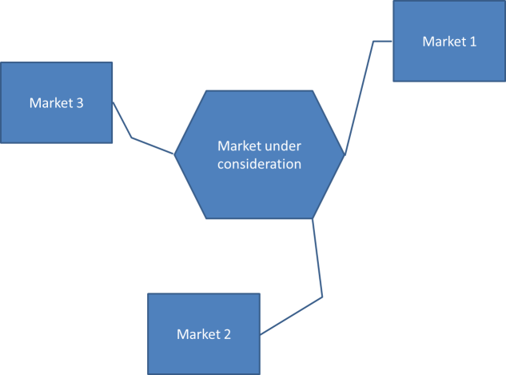6.5 To clarify the steps described, a worked example will be followed based on the hypothetical situation below, optimising (with example values) the capacities, reinforcements and connection locations of potential interconnections to the market under consideration:

*Figure 5 Example markets*

6.6 For this methodology, capacity refers to the bidirectional capacity between two markets - this can be achieved through any number of interconnectors. A distinction must be maintained between the capacity before and after losses on interconnectors - that is, a 1000MW interconnector with 10% losses may have a total capacity of 1111MW, or in actuality only be able to flow 900MW of useful power, losing the difference in conversion and normal transmission losses.

### Modelling inputs

6.7 The starting point of the process is National Grid’s Future Energy Scenarios (FES) which include generation plant ranking orders and demand forecasts for each scenario, and ETYS, which outlines boundary capabilities and planned reinforcements per scenario. Due to time constraints, those reinforcements recommended by this year’s NOA cannot be included, as those recommendations will not be available until too late for the NOA IC analysis to be undertaken. The ranking order for each scenario contains existing and planned / proposed interconnectors.

6.8 The time period considered in the studies extends from the present to 2035. This is to match the FES, which forecasts up to 2035 in detail, and up to 2050 at a high level. Some runs can be accelerated with a ‘spot year’ approach - only probing years 2022, 2026, 2030 and 2034 for example.

### Copperplate model

6.9 The purpose of a copperplate model is to find the flows a link, or set of links, would experience if the various European networks were connected to GB by links of infinite capacity. The relative size of these flows then reflects the combined markets’ optimal dispatch solution such that the cheapest possible set of plant is always that which meets demand. The flows on the country to country links thus show where the market dictates extra capacity would be useful. The size of capacities this model suggests will be erroneous due to loop flows and failure to consider inefficiencies of interconnectors; it does, however, reflect the relative usefulness of links to the various European markets and provide a starting point for a more refined search of potential capacities. Rather than using the maximum flow observed in simulation, a value that encapsulates 80% of the flows is used (referred to as the P80 value) - this removes unrealistically high values that can be generated by a completely unconstrained model, fed by loop flows, and potentially the approach taken by the solver.

*Figure 6 Example flow duration curve from copperplate simulation - for illustration only*

6.10 In the example shown, the starting point for the capacity optimisation would be 2000MW, as 80% of the copperplate flows were less than this value.

*Table 3 Example copper plate flows*

|  |  |  |  |
| --- | --- | --- | --- |
|  | Copper plate flows | | |
|  |
|  | Max flow | P80 | Rounded P80 |
| Market 1 | 4426 | 3562 | 3500 |
| Market 2 | 3214 | 2612 | 2500 |
| Market 3 | 4112 | 3170 | 3250 |

### Market Modelling

6.11 An alternative method of arriving at a recommendation for capacity development is an iterative optimisation per scenario. It is presented here, along with the permutation based approach outlined above, as both avenues remain open at this time, with different strengths to each. The final decision on which to use will be taken following further consideration of the capabilities of the new Market Modelling tool at the SO’s disposal, BID3, and the opinions of stakeholders.

6.12 The iterative optimisation approach attempts to maximise SEW – CAPEX using a search strategy. The whole process is repeated four times to arrive at an optimal development of capacity in each of the four FES. In common with the permutations strategy, a balance between computing resource and rigour in each step of the process must be struck. An example step is outlined below, wherein multiple capacity changes are evaluated for SEW in each step, and that capacity change which yielded the best result is kept in the next step. Note that engineering judgement could be employed to avoid searching solutions which are deemed unlikely to yield high SEW – CAPEX results. This neglect of search steps would, as with the alternative approach, be subject to meeting two conditions: a reasonable justification for the assumption it would not have a high [SEW - CAPEX] value, and it’s inclusion in the modelling must cause an undesirable strain on modelling resources.

6.13 Timing of capacity increases can affect the SEW generated by the interconnection across the study window. Within each search step, therefore, timing combinations should also be checked (for example, testing the commissioning of an extra 500MW in 2022 and 2026 to determine which is preferable). Again, this is subject to the need to only check realistic permutations within the search to allow the convergence of an answer within reasonable timescales. The use of spot years would be necessary to allow a solution to converge, wherein the commissioning of additional projects would be evaluated only in certain future years. The table below does not show the inspection of different years of commission for clarity.

*Table 6 - Example of iterative search step*

|  |  |  |  |  |  |  |  |
| --- | --- | --- | --- | --- | --- | --- | --- |
|  | Iteration 1 Transfer Capacities (MW) | | | | | | |
| Baseline | Simulation 1 | | Simulation 2 | | Simulation 3 | |
| Increment | Simulated value | Increment | Simulated value | Increment | Simulated value |
| Market 1 | 2000 | +500 | 2500 | 0 | 2000 | 0 | 2000 |
| Market 2 | 1000 | 0 | 1000 | 500 | 1500 | 0 | 1000 |
| Market 3 | 1000 | 0 | 1000 | 0 | 1000 | 500 | 1500 |
| **CHANGE IN SEW - CAPEX** | **0** | **+ £7M** | | **+ £3M** | | **+ £11M** | |
|  | Iteration 2 Transfer Capacities (MW) | | | | | | |
| Baseline | Simulation 1 | | Simulation 2 | | Simulation 3 | |
| Increment | Simulated value | Increment | Simulated value | Increment | Simulated value |
| Market 1 | 2000 | +500 | 2500 | 0 | 2000 | 0 | 2000 |
| Market 2 | 1000 | 0 | 1000 | 500 | 1500 | 0 | 1000 |
| Market 3 | **1500** | 0 | 1500 | 0 | 1500 | 500 | 2000 |
| **CHANGE IN SEW - CAPEX** | **0** | **+ £6M** | | **+ £2M** | | **+ £5M** | |

6.14 The search finishes when it is deemed to have converged- that is, no further capacity alterations yield a higher overall SEW - CAPEX for the whole study window. The optimal capacity profiles would then be presented in the NOA report, providing the industry not with a single recommendation, but a range of optimal capacities against each of the FES, with which to judge where the best opportunities for further interconnection lie.

## Process Output

7.1 The above methodology will be employed to create a chapter of the NOA 2017 report. This chapter will present the main findings of the analysis - per scenario, an optimised interconnection capacity level by market, and the most plausible connection zones per market. This will be delivered by 31st January, 2017.