Grid Code Review Panel Elections 2022
Nomination Form
What do I need to know?

How often does this election process take place?
Every 2 years, the Grid Code Review Panel and Alternate members are either elected or appointed into position in accordance with the Grid Code Governance Rules (Annex GR.A). National Grid ESO, as Code Administrator for the Grid Code, operates this election process.

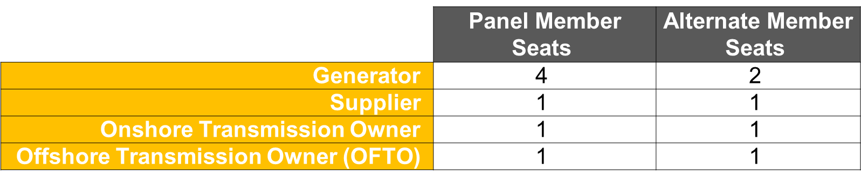
How many seats are available for election?

For the avoidance of doubt, this election does not apply to any other seats on the Grid Code Review Panel.

How do I nominate somebody to become a Panel Member?
CUSC Schedule 1 Users and Materially Affected Party’s as of 31st August 2022, may nominate one candidate to stand for election by completing and returning this nomination form. Parties may only nominate a candidate for their own category, e.g., a Supplier may only nominate a candidate for the Supplier Panel Member seat. If Parties belong to more than one category, then they may nominate a candidate for each of the categories that they represent.

What are the key milestones in the process?
Date | Milestone
Monday 5th September 2022 | Invitations sent out to CUSC Schedule 1 Users/Materially Affected Parties to nominate candidates to stand for election.
Friday 30th September 2022 | Nomination Forms to be returned no later than 5pm.
Monday 10th October 2022 | List of candidates and voting papers to be circulated, or we will announce the outcome of the elections.

Do I need to do anything?
Please complete the attached form below with your nomination and email it to us at: grid.code@nationalgrideso.com by 5pm on 30th September 2022. Please ensure that all sections are completed by the relevant party.

Any Questions? Please contact: grid.code@nationalgrideso.com

Grid Code Review Panel Nomination Form*

PART A – NOMINATION

Name of Candidate: …………………………………….

Seat nominated to be elected to: ……………………..

I nominate the above-named person to stand as a candidate in the Grid Code Review Panel
2022 Election:

Name: ……………………………………………...

Company: …………………………………………

Election Reference Number: ……………………...

Please note: Parties may only nominate a candidate for their own category:
- A Supplier may only nominate a candidate for the Supplier Panel Member seat and a Generator may only nominate a candidate for the Generator Panel Member seat etc.
- If Parties belong to more than one category, then they may nominate a candidate for each of the categories that they represent.

Alternative Panel Member Seats:

Should you not be successful in securing a Panel Member seat within your Category (Supplier, Generator, Offshore Transmission Owner and Onshore Transmission Owner) through the election process please indicate whether you would wish to become an Alternate Panel Member for your category:

[Yes/ No]

PART B - DECLARATION BY CANDIDATE

I, [candidate name] confirm that I accept the above nomination to stand for candidacy in the forthcoming Grid Code Review Panel Elections.

I confirm that I have read the Governance Rules of the Grid Code and I understand my responsibilities as a Panel Member and my ability to stand as a member of the Grid Code Review Panel. In particular, I declare that I am not prohibited from holding office as a Member of the Panel by virtue of the provisions within the Governance Rules of the Grid Code.

I confirm that upon being elected/appointed that I accept the responsibilities in relation to the role of a Grid Code Review Panel Member and I agree to act in the capacity of a Panel Member by committing to the following:

- To act impartially and in accordance with the objectives of the Grid Code.

- To not represent, or have regard for the particular interests of:

  - the body or persons by whom I was nominated as a Panel Member; and
  - any Related Person from time to time (including my employer, companies or businesses in which I or a close family member has a significant vested interest in.)

- To disclose in writing to the Panel Secretary, at the time of nomination, appointment or upon any change in such interests, mentioned within (ii), that I may have in relation to the Grid Code.

For the avoidance of doubt these expectations apply to a Panel Member and Alternate Member.

PART C – DECLARATION BY EMPLOYER

We, [Employer name as stated on electoral roll] confirm that we are the employer of, [candidate name].

We agree that if the candidate is successfully elected/appointed, we will provide a letter in writing agreeing to the appointment of the candidate as a Panel Member and acknowledge that the requirements, as set out in within Part B above, will prevail over the candidates’ duties as an employee.

Name: ………………………………………………………

Position: ……………………………………………………

E-mail Address: …………………………………………...

Date: …………………………………………………………

PART D - CANDIDATE STATEMENT
Please use this section to give a brief overview of the candidate and their credentials. This will be included within the election material sent out to voters.
…………………………………………………………………………………………………………………………………………………………………………………………………………………………………………………………………………………………………………………………………………………………………………………………………………………………………………………………………………………………………………………………………………………………………………………………………………………………………………………………………………………………………………………………………………………………………………………………………………………………………

Please note: for your nomination to be considered all fields of this form* are required to be completed and sent to grid.code@nationalgrideso.com by no later than 5pm on 30th September 2022.

*For the avoidance of doubt, Parts A and C must be completed by the CUSC Schedule 1 or Materially Affected Party. Parts B and D must be completed by the candidate nominated for election.

