Firm Frequency Response (FFR) Market Information Report for October 2020

Published
August 2020

Key Points

This Market Information Report is relevant for tenders submitted in Sept 2020 for delivery in October 2020.

Tenders from eligible service providers for Firm Frequency Response should be submitted on
Tue 1st September 2020 (1st business day) for all tenders.

National Grid will notify service providers of the outcome of the tender assessment, and preliminary nominations, by Wed 16th September 2020 (12th business day).

From January 2018, non-compliant tenders will be rejected prior to assessment.

Providers must use the template provided in the Ariba system to tender in for FFR. Use of any other template or submissions via e-mail will not be accepted.

In line with the standardisation outlined in the Product Road Map, procurement of FFR will only take place across the standard 6 EFA blocks. Tenders must therefore only start, and end, at the following times: 2300, 0300 0700 1100 1500 1900. Submitted tenders must have a minimum window availability of 4 hours in line with EFA blocks.

Please note that this is a month ahead only tender. Tenders should therefore be submitted for Oct 2020 delivery.

The details regarding the dates, times and dial in details for the upcoming FFR Result WebEx can be found here.

Real-time data i.e. demand and frequency data, over the last 60 minutes can now be found on the Realtime Extranet section on the National Grid website. Historic frequency data as far back as 2014 can also be accessed for GB data at 1 second resolution.

For further information please contact your account manager or:
Andrew Rice
Andrew.Rice@nationalgrideso.com
This Market Information Report provides information to FFR providers on the requirement for the tender (TR 129) for delivery in October 2020.

Requirements for October 2020 (TR 129)
Primary Response:
A dynamic primary requirement exists in all EFA blocks.

Secondary Response:
A dynamic primary requirement exists in all EFA blocks.

Non-dynamic secondary requirement exists in EFA blocks 3 - 6.

High Response:
A dynamic primary requirement exists in all EFA blocks.

A breakdown of the outstanding requirement for this tender round can be found in Appendix 1. A full breakdown of the long-term requirements can be found in Appendix 1 in the Excel file.

Market Updates

New Suite of Products

Please refer to new Dynamic Containment page for details related to the new suite of products.
The soft launch of new Dynamic Containment is scheduled for this autumn.

Following the webinar we hosted 18/8/20 on Dynamic Containment, the FAQ is now ready to be viewed here. We will continue to update the FAQ log ahead of the soft launch.

Please look out for updates as we will be hosting a series of webinars to keep you updated and answers any questions you may have regarding the new service.

In order to implement the new product suite, and avoid overholding of response volumes, it will be necessary to gradually reduce our long-term procurement of the existing P S H products. We will continue to hold monthly FFR tenders for month ahead volume.

Response BOA and Holding Volume and Cost
This information is in Appendix 7 of the adjoining excel file.

FFR service Overview
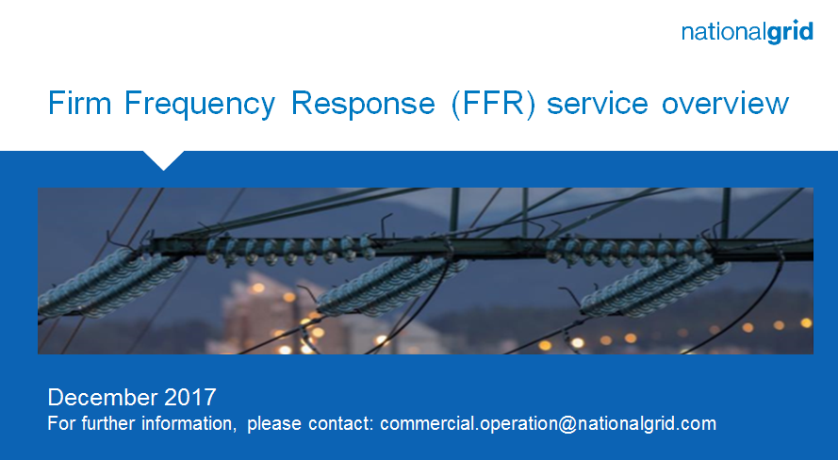

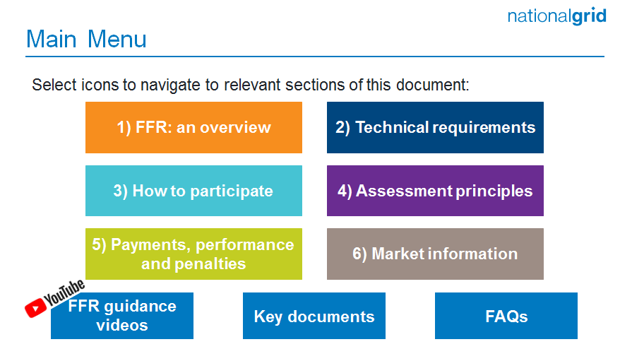Interactive guidance document

Product Roadmap
This document sets out the actions to be taken forward for frequency response and reserve.

September 2020 FFR Delivery

145 active FFR contracts are due to provide FFR in September 2020. These contracts are made up of:

- 120 dynamic contracts
- 25 non-dynamic contracts
- 33 contracts by BMU providers
- 112 contracts by NBMU providers

The chart below displays the number of tenders submitted in the FFR market for the last 12 months by service type.

Key messages

Testing
Providers are required to have successfully passed FFR testing of their asset by the National Grid Generator Compliance Team prior to tendering in for month ahead delivery. E.g. If tendering to provide a FFR service starting on 1st Oct 2020, the unit must have passed testing prior to the tender submission window closing on the 1st business day in Sept 2020. Tenders that do not meet this requirement will be deemed non-compliant and automatically rejected.

Limiting tenders
Providers are limited to submitting 3 tenders per unit, per tender period. A tender period is considered to be; month ahead, quarter ahead and per season. All-or-nothing bids will be considered as 1 tender submission.

EFA Block Procurement
For providers wishing to start a tender on the last day of the previous month, these tenders cannot start earlier than 2300 or they will be deemed as non-compliant.
The minimum requirement across each specific EFA block will determine how much volume will be procured for each of the 6 daily 4-hour blocks.
Any outstanding shape will be satisfied, where necessary, closer to real time by the Electricity National Control Centre.

Enhanced Frequency Response (EFR)
100% of EFR is included in the requirements from July 2018.

Procured Volume
As system conditions are changing, we have increased the requirement of dynamic frequency response to manage our pre-fault frequency. Our total response requirement remains unchanged. We have monitored the use of MFR to meet the increased requirement for several months and we are confident this requirement should be released to the FFR market. This was released in TR118 moving procurement to the open tendered market.
No. | FFR Reason Code | Comment
1 | Beneficial | While the price submitted was considered  beneficial, on this occasion this tender was not  accepted for one of the following reasons:  - The outstanding or desired procurement requirement has already been satisfied by more beneficial tenders  - There was no outstanding requirement  - The desired volume against the National Grid procurement strategy for future tender months had already been satisfied  - This tender formed part of an all-or-nothing group which did not collectively deliver enough benefit to be considered
2 | Price not beneficial across tendered period | The price submitted was too high and did not provide any contract benefit against alternative actions including the mandatory and optional market.
3 | Does not meet tender prerequisites | Please refer to the 'Technical Parameters' section using the following link to determine the criteria necessary to participate in the FFR market https://www.nationalgrid.com/uk/electricity/balancing-services/frequency-response-services/firm-frequency-response
4 | Multiple tenders received for the same unit | Only the most valuable tender(s) of the total group of submitted tenders was considered.
5 | Beyond desired procurement volume | Tenders submitted contained volume in a period where no procurement volume existed

The weekly auction trial started on 28th November 2019. In order to bring the procurement closer to real time that can reduce barriers to entry, we will procure part of this FFR dynamic volume through the weekly auction. We have moved 100MW of dynamic primary, secondary and high response from FFR monthly into the FFR weekly auction.

When determining which tenders to accept, NGESO will take account of its planned procurement strategy. In general, a measured approach is taken to determine the appropriate volume to procure throughout the duration of the tender.
Tender rejection codes
The table below provides guidance as to the reasons why a tender has been rejected. They can be matched against the numbers in the ‘Reason Code’ section of the Post Tender Report.

Appendix 1:
Nov-18
Requirement Volume Tables

Dynamic High requirement still remains across the whole day however overnight tenders would be considered where more value is observed.

A breakdown of the outstanding month ahead requirement for this tender round.

Dynamic FFR requirements for TR 129 Non-Dynamic FFR requirements for TR 129
EFA Block | Dynamic or Non-Dynamic  Response Required (MW)
 | Primary | Secondary | High
1 | 0 | 0 | 0
2 | 0 | 0 | 0
3 | 0 | 71 | 0
4 | 0 | 96 | 0
5 | 0 | 85 | 0
6 | 0 | 78 | 0
EFA Block | Dynamic Response Required (MW)
 | Primary | Secondary | High
1 | 362 | 362 | 362
2 | 362 | 362 | 362
3 | 450 | 450 | 450
4 | 450 | 450 | 450
5 | 450 | 450 | 450
6 | 450 | 450 | 450

Appendix 2:
October 2020 Requirements

The three charts below display the volume of frequency response left to contract at month ahead against the total response requirements.

For month ahead only, except for circumstances where there is a specific dynamic requirement, the requirement will be taken from either dynamic or non-dynamic providers where deemed economic to do so. This means that any requirement found in the non-dynamic market may be procured in the dynamic market if considered more beneficial. With no primary non-dynamic market in existence, procurement of this volume across any EFA block will instead be taken from the dynamic market.

The breakdown of the requirement against dynamic and non-dynamic response can be seen in the tables in appendix 1.

In the move to standard EFA block window durations, the minimum of the total requirement across each EFA block outlines the level to be procured. In light of this transition, the minimum dynamic requirement remains a key component to be satisfied and outstanding volume against this will continue to be procured for operational purposes. For Oct-20, this is highlighted in the table in Appendix 1.

