

CONSULTATION DOCUMENT VOLUME 1

Urgent CUSC Amendment Proposal CAP168

Transmission Access
Under-use and reallocation of TEC

The purpose of this document is to
consult on Urgent Amendment Proposal CAP168
with CUSC Parties and other interested
Industry members

Amendment Ref | CAP168
Issue | 1.0
Date of Issue | 17th April 2009
Prepared by | National Grid

Responses to this consultation should be sent to sarah.a.hall@uk.ngrid.com by the 1st May 2009

I DOCUMENT CONTROL

a National Grid Document Control
Version | Date | Author | Change Reference
0.1 | 15/4/09 | National Grid | Draft for Comment
1.0 | 17/04/09 | National Grid | Final Version

b Distribution
Name | Organisation
The Gas and Electricity Markets Authority | Ofgem
CUSC Parties | Various
Panel Members | Various
National Grid Industry Information Website

II CONTENTS TABLE

SUMMARY AND RECOMMENDATIONS 3
PURPOSE AND INTRODUCTION 4
PROPOSED AMENDMENT 5
SUMMARY OF WORKING GROUP DISCUSSIONS 10
WORKING GROUP ALTERNATIVE AMENDMENTS 20
ASSESSMENT AGAINST APPLICABLE CUSC OBJECTIVES 22
PROPOSED IMPLEMENTATION 25
IMPACT ON NATIONAL GRID IS SYSTEMS AND RESOURCES 25
IMPACT ON THE CUSC 26
IMPACT ON INDUSTRY DOCUMENTS 26
WORKING GROUP VIEW/RECOMMENDATION 26
NATIONAL GRID INITIAL VIEW 27
INDUSTRY VIEWS AND REPRESENTATIONS 28
ANNEX 1 – CAP168 CUSC Amendment Proposal 29
ANNEX 2 – CAP168 Working Group Terms of Reference 38
ANNEX 3 – WORKING GROUP ATTENDANCE REGISTER 42
ANNEX 4 – RESULT OF WORKING GROUP VOTE 43
ANNEX 5 – ANALYSIS FROM NATIONAL GRID PRE-CONSULTATION 44
ANNEX 6 – FURTHER ANALYSIS 46
ANNEX 7 – FURTHER DETAILS OF USER COMMITMENT 49
ANNEX 8 – LEGAL TEXT TO SUPPORT THE PROPOSAL 56

1.0 SUMMARY AND RECOMMENDATIONS

  - Executive Summary

    - CAP168 Transmission Access – Under-use and reallocation of TEC was proposed by ConocoPhillips and submitted to the CUSC Amendments Panel for consideration at their meeting on the 27th February 2009. CAP168 was given Urgent status to ensure it could be assessed by the Authority along side the other Transmission Access Amendment Proposals (CAP161-CAP166).

    - The CAP168 Original Proposal includes the following main features:
- The introduction of an under-use charge for Transmission Entry Capacity (TEC);
- Offering TEC to the market or System Operator (SO);
- A “use it or lose it” mechanism (Feasibility test);
- User commitment; and
- A capacity reduction charge

    - Through consideration of CAP168 by the Working Group the Original proposal has been developed. One Woking Group Alternative Amendment known as Working Group Alternative Amendment One (WGAA1) has also been developed.

    - CAP168 has been developed against the background of the other Transmission Access Amendment Proposals (CAP161-CAP166). It did not seem appropriate for the Working Group to repeat previous work from the Transmission Access Working Groups given that CAP168 was given Urgent status in order to be assessed along side these other Amendment Proposals. The Working Group agreed that for CAP168 to be fully effective CAP161-CAP163 would need to be approved.

  - Working Group Recommendation

    - The Working Group has developed the Amendment Proposals (Original and WGAA1) to the extent possible given the Urgent timetable. Several substantial developments have been made to the Original Proposal through the discussions of the Working Group. However, the tight timescales have limited the ability of the Working Group to fully incorporate some aspects of the Originals Proposal, in particular two day ahead notifications.

    - The Working Group recommended to the CUSC Panel that:

- A Consultation Report containing the CAP168 Original Amendment and WGAA1 should proceed to wider Industry Consultation as soon as possible.
- The Working Group Report is accepted by the CUSC Panel and the Working Group is disbanded.

    - The Working Group voted on whether they believed the Amendment Proposals (Original and WGAA1) better, than the current baseline, facilitates the Applicable CUSC Objectives. The results of the vote are described in the following table:

Proposal | Better | Not better | Abstained
Original | 0 | 13 | 1
WGAA1 | 1 | 11 | 2

    - The Working Group voted on which version of CAP168 (Original and WGAA1) they believed best facilitates the Applicable CUSC Objectives. The results of the vote are described in the following table:

Proposal | Best
Original | 4
WGAA1 | 1
Abstained | 9

    - Four members of the Working Group voted that the Original was the best. It should be noted that these members also voted that the Original was not better than the baseline. One Working Group member voted that WGAA1 was best. This member also believed that WGAA1 was better than the baseline.

    - Nine Working Group members abstained. One of these Working Group members abstained as they would have another opportunity to vote as they were on the CUSC Panel. One member abstained as given the precedent set under CAP170 they were concerned that the Alternative (WGAA1) should not have been raised as an Urgent CUSC Amendment. One member pointed out that the Alternative (WGAA1) would potentially free up more capacity but puts more of a risk on generators. This member abstained as the balance of impact of these two aspects is difficult to assess at this stage. Some members abstained because they believed neither the Original nor the Alternative (WGAA1) better facilitated the CUSC Objectives.

2.0 PURPOSE AND INTRODUCTION

  - This is a consultation document issued by National Grid under the rules and procedures specified in the Connection and Use of System Code (CUSC) as designated by the Secretary of State.

  - CAP168 was proposed by ConocoPhillips and submitted to the Amendments Panel for their consideration on 27th February 2009. The CUSC Amendment Proposal Form can be found in Annex 1 of this report.

  - The proposer requested Urgent status so that the proposal could be assessed along side the other Transmission Access related Amendment Proposals. The Amendment Panel agreed that the proposal should have Urgent status and submitted a request for Urgent status. Ofgem agreed with the Urgent recommendation and the proposed timetable.

  - Due to the urgency of this proposal, time did not allow for a Working Group consultation. In order to have some wider industry input National Grid published a pre-consultation on the 10th March 2009 based on the Original Amendment Proposal. Seven responses were received and these were considered during the Working Group discussions. Whilst not a formal Working Group consultation, these responses can be found in Volume 2 of this report for information to assist respondents to the Company Consultation.

  - The Working Group met on the 13th March 2009, and the members accepted the Terms of Reference for CAP168 with minor amendments. A copy of the Terms of Reference is provided in Annex 2. Two further meetings were held on the 19th and the 24th of March 2009. The Working Group considered the issues raised by the Amendment Proposal and considered whether the Proposal better facilitated the Applicable CUSC Objectives.

  - CAP168 Working Group Report was submitted to the CUSC Amendments Panel meeting on 3rd April 2009. The Amendments Panel determined that CAP168 was appropriate to proceed to wider industry consultation by National Grid.

  - This consultation document outlines the discussions held by the Working Group and the nature of the CUSC changes that are proposed. Representations received in response to this consultation document will be included in National Grid’s Amendment Report that will be furnished to the Authority for their decision.

  - The Amendment Proposals (Original and WGAA1) aim to incentivise Users to release TEC. Against the current baseline it is envisaged that CAP168 would incentivise Users to trade TEC under the CAP142 arrangements. However, the Working Group recommends that CAP161-CAP163 should be approved in addition to either the Original Amendment Proposal or the Alternative (WGAA1).

  - This consultation document has been prepared in accordance with the terms of the CUSC. An electronic copy can be found on the National Grid website, along with the Working Group Report for CAP168 and the Amendment Proposal form:

http://www.nationalgrid.com/uk/Electricity/Codes/systemcode/amendments/

Responses to this consultation should be sent to sarah.a.hall@uk.ngrid.com by the 1st May 2009

- PROPOSED CAP168 ORIGINAL AMENDMENT

This section describes ConocoPhillips’ Original CAP168 Amendment Proposal and includes several clarifications and developments that have resulted from Working Group discussions. The full text of the Original Amendment Proposal can be found in Annex 1.

  - Defect

    - This Amendment Proposal seeks to address a number of defects which, in the view of the proposer of CAP168, exist with the current entry access arrangements.

    - Under the existing transmission access arrangements a long queue of applications for new connection capacity has developed. There is significantly more demand for access than available unallocated capacity, and some generators may be constrained or delayed or even not able to develop owing to lack of secure transmission access in usable timescales. To compound matters there is presently little incentive for existing transmission access right holders to release TEC when it is not being used.

    - Although there is already scope for securing additional access (under CAP70 and CAP94) and for limited trading (CAP142) within-year, the proposer considers the current rules are deficient to deliver robust trading of TEC rights. There is currently no incentive for Users to give up TEC within year as the TNUoS charge for TEC is an annual charge and therefore a sunk cost within year. Consequently TEC holders can be unwilling or unable to give up TEC they know they will not use in the short to medium term but which they expect to need in the medium to long term as they could lose all future rights to that released capacity, hence no liquidity has developed in the TEC trading market. As a result the System Operator (SO) has an inaccurate picture of available system capacity and any local surplus.

  - Description of CAP168 Original Amendment Proposal

TEC Feasibility Test

    - As soon as Practicable after each charging year each generator would need to show to the SO that it could meet a feasibility test. Demonstration of this would be in the first instance on the basis of historic output. Up to the previous five years of output would be reviewed. The test would be failed if the holder could not demonstrate their TEC (MW) has been used (or assigned to another user) in the previous two consecutive financial years, or three financial years in the previous five.

    - In the event that a TEC holder did not meet the test, the generator would be able to provide a rationale for reduced operation due to either (a) exceptional factors historically (e.g. long-term outage) or (b) change in future output due to remedial plans or new investment works such that it would be able to use its TEC (MW) in future years.

    - If the rationale provided by the TEC holder is not sufficient, the SO may require the production by the TEC holder of an engineering report at the TEC holder’s cost. If there were still a dispute, there would then be an appeal to the Authority.

    - If after due process the Authority upholds the SO’s assessment and the SO decided to reduce the TEC (MW) level then an adjustment would be made to the relevant bilateral contract.

Firm Weekly TEC Notification

    - The TEC holder would be required to provide a weekly TEC (MW) level notification. This would oblige them to submit to the SO their expected maximum MW capacity in any one settlement period in a given week. This notification should be provided five weeks ahead of the week in question. The notification would be provided on a weekly basis in accordance with the following timetable:

Week 1 |  |  |  |  |  |  | Week 2 |  |  |  |  |  |  | Week 3
M | T | W | T | F | S | S | M | T | W | T | F | S | S | M | T | W | T | F | S | S
 | A
 |  |  |  |  |  |  |  | A
Week 4 |  |  |  |  |  |  | Week 5 |  |  |  |  |  |  | Week 6
M | T | W | T | F | S | S | M | T | W | T | F | S | S | M | T | W | T | F | S | S
 |  |  |  |  |  |  |  |  |  |  |  |  |  | B
Week 7 |  |  |  |  |  |  | Week 8
M | T | W | T | F | S | S | M | T | W | T | F | S | S
C
B |  |  |  |  |  |  | C

A – Generators submit Weekly TEC Nomination by 16:00hrs
B – Week starts from 05:00hrs
C – Week ends at 04:59hrs

    - The TEC holder would also provide indicative maximum TEC estimates for the ensuing three subsequent weeks but these would be for information only. Details of Users weekly TEC notifications and estimates would be confidential.

TEC Trading Arrangements

    - To ensure that other Users have the ability to use the capacity released CAP161-CAP163 would need to be approved alongside this Amendment.

Calculation of Under-use and Over-use Capacity

    - The under-use and over-use capacities shall be calculated as the difference between the firm weekly TEC MW notification (expected maximum MW capacity in any one settlement period in a given week) and the actual maximum capacity in any settlement period (MW average over a whole settlement period) in the given week net of any balancing service. Users who provided Balancing Services or provide BM actions (reserve or response) would have their under/over-use charge adjusted to take account of the capacity contracted to the System Operator. The proposal makes no allowance for plant that has modified TEC requirements due to short term trading to cover plant or demand shortfalls in the market.

    - Under-use occurs where the actual output (MW) is less than the notification (MW) and over-use occurs where the actual output (MW) is more than the notification (MW). For the avoidance of doubt Entry Overrun for output in excess of TEC held within a Users Bilateral Connection Agreement and described in CAP162 would be in addition to over-use under CAP168.

Under-use Capacity
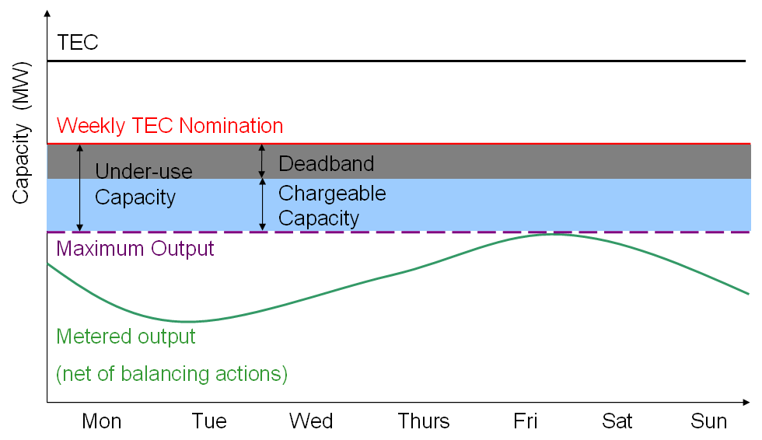

Over-use Capacity
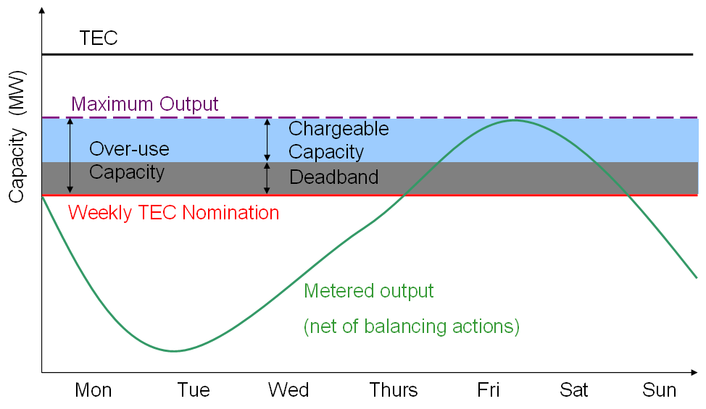

Calculation of Under-use and Over-use Charge

    - Under-use and over-use charges would be in addition to existing use of system payments and be developed under charging governance.

    - The under-use charge shall be applied as a function of any under-use (MW) capacity above a dead band of the greater of 5MW or 10% of the generators TEC (MW) holding.
Pre-commissioning User Commitment

    - Pre-commissioning Users would be required to provide the following profile of pre-comissioning liabilities and securities. Further details regarding user commitment can be found in Annex 7.

t

£
Offer
Signature
Completion
Date
Trigger
Date
At “t” Cancellation Amount =
Termination Amount x 100% =
3 x Generation TNUoS tariff

t-1

t-2

t-3

t
25%
50%
75%
100%
User Commitment Amount
Amount
Cancellation Amount
£1/kW
£2/kW
Max
£3/kW
Subject to a maximum of Termination Amount x 25%

Post-commissioning User Commitment

  - Users would be required to give two full years notice of TEC (MW) capacity reduction. Where two years full notice has been given no transmission charges would be incurred once the plant has closed. If two years’ full notice was not give the User would be liable for two years’ worth of TNUoS charges in addition to the existing year.

4.0 SUMMARY OF WORKING GROUP DISCUSSIONS

  - Introduction of an Under-use Charge for TEC

    - Although the introduction of an under-use charge would need to be taken forward as a modification to the Charging Methodology, the under-use charge is a fundamental part of the Original CAP168 Amendment Proposal. Due to the fundamental nature of the under-use charge as part of the proposal the Working Group gave the matter consideration.

Negative Zones

    - The Working Group considered whether the charge should apply in negative charging zones. During its pre-consultation National Grid provided some analysis to show where capacity was being under used. This analysis can be found in Annex 5. In negative zones around 10% of TEC was unused. This was broadly the equivalent to Scotland (11%) but substantially more than positive zones in England and Wales (3%). This suggested to some Working Group members that there was a problem with User’s overbooking TEC in negative zones.

    - In negative zones Users are incentivised to hold the correct level of TEC on an annual basis because the TNUoS model uses the TEC they hold to calculate their annual charge. If they hold more TEC than they require their tariff will be less negative, so when they come to be charged based on their output over winter they would be paid less. One member of the Working Group argued that this was similar to the incentive on Users in positive zones where a User’s TNUoS charge was based on the TEC they had booked. If they held more TEC than they required the charge calculated by the charging model would be greater. One member of the group noted that TNUoS did not incentivise Users to hold the correct level of TEC in the short term.

    - Some members of the Working Group were concerned about what would happen to Users whose charge changed from positive to negative or vice versa over a number of charging years. It was agreed this would not be a problem if positive and negative zones were treated similarly under CAP168.

    - On balance the Working Group agreed an under-use charge (based on the absolute (or modulus) of the charge) should be applied in negative zones on a similar basis to its application in positive zones. Further discussion regarding the level of the charge can be found in later in this report.

Plant Operation

    - Some members of the Working Group noting the technical aspects of power station operations believed that the MW capacity that the under-use charge was based on should allow a margin for headroom. This would mean that a User would not be charged for under-use if they had only used slightly below their TEC holding. The Working Group considered that giving each power station a margin (or “dead-band) over the whole network would add up to a large amount of capacity but that this may be more relevant a concern for the feasibility test/”use it or lose it” arrangements than for charging .

    - A deminimis level of 5MW was proposed for the under-use charge. If applied to both the under and over-use charges this would lead to a total 10MW dead-band around the TEC notification. Some members of the Working Group suggested that having a dead-band level of 5MW on the under-use charge was not great enough for large generators. These members suggested that 10% of total TEC would be a more appropriate dead-band level. Other members of the Working Group suggested that having a 10% allowance may disadvantage smaller players. There was also some concern that having a level of 10% of TEC could dilute the intension of the amendment.

    - Following a vote the majority of the Working Group considered the dead-band level should be the greatest of 10% of TEC or 5MW. This would mean if a 500MW generator under used by 57MW the under-use charge would be a function of 7MW.

    - One Working Group member suggested that there should be an alternative based on a 5MW dead-band only (in other word no ‘%’ allowance as described in 4.1.7-4.1.8). This became the basis of WGAA1. Further details of this Alternative can be found in section 5 of this report.

    - Respondents to the pre consultation (see Volume 2) and some members of the Working Group highlighted the unique operation of some generation plant types. The Working Group considered that some Users may need their full TEC but may not use it very often because they are peaking plant or held in reserve. The Working Group considered whether some Users should be exempt from the under-use charge.

    - Working Group members were concerned with the interaction between the shorter term energy market and ability to provide energy and reserve services to either the System Operator or other market players. One Working group member pointed out that some 3-6 GW is traded base load day ahead. This results in the potential re scheduling of a significant number of BMU’s. Plant that ultimately delivers this energy will only be able to know its full TEC (MW) requirement after trading has taken place. Trading can take place up until gate closure. The CAP168 Amendment Proposal would significantly affect the operation of this section of the market with a significant reduction in short term liquidity. Any changes to the plant availability or demand after the week ahead TEC (MW) nomination would not be able to be catered for without the addition of over/under use costs.

    - One Working Group member suggested that the introduction of CAP168 would not reduce short-term liquidity. This Working Group member suggested that if unused TEC is reallocated it might increase liquidity.

    - Some Working Group members thought that the modification was designed for plant that has very predictable running patters such as base load CCGT. One Working Group member voiced concern that the proposed under/over use charges should be levied based on weekly actual TEC (MW) use against forecast TEC (MW) use will inevitably seriously penalise windfarms whose output is difficult to predict on anything other than a very short term basis. This member was concerned that the CAP168 Amendment Proposal, as drafted, would most probably prompt windfarms to forecast their weekly TEC (MW) requirement equal to the windfarm installed (MW) capacity which would mean that for every week where the wind has been insufficiently strong to generate at full (MW) capacity then the windfarm would incur an under use charge on top of its regular TNUoS charges. This Working Group member suggested that the granularity for applying these under/over use charges should be over a whole year for windfarms in recognition of the special nature of this form of generation and believed that windfarms should be treated as an exemption in this respect in view of their inability to accurately forecast output.

    - Some Working Group members considered the CAP168 Amendment Proposal was not suitable for a market where changes in demand and generation need to be catered for after the week ahead period. There was a discussion as to whether plant that operates in the short term (after week ahead) would be catered for. The proposer suggested that peaking plant could be excluded from the under and over-use charges. Peaking plant would be defined as plant that runs for less than 500 hours in a charging year. Some members believed this exemption was necessary to ensure security of supply. Other members considered that 500 hours was not well defined enough.

    - The Working Group agreed Users providing balancing services to the SO would have the MW capacity associated with those services netted with their actual output MW so would avoid the charge where appropriate i.e. if the System Operator instructed reduced output this should not incur a charge.

    - Some Working Group members considered that National Grid took into account the type of plant being connected when they planned the network according to the GBSQSS. It was considered that National Grid would make conservative assumptions. If Users made decisions about how much TEC (MW) they required National Grid would have firmer information. The Working Group considered the charge could be seen as an information imbalance charge. It was noted that if approved CAP162 (overrun) in combination with TNUoS charges would already incentivise Users to better optimise TEC holding as Users could opt to pay for less TEC in the long-term and use over-run.

Level of Charge

    - The Working Group had some concern that introducing an under-use charge changes the nature of the generators holding of TEC from, currently, a right to access the system to having an obligation to run. There is an important difference between an obligation to run and an incentive to make available unused TEC. The Working Group considered that any under-use charge should aim to incentivise users to give up TEC but not compel them to give it up. This would mean that Users could choose to pay the charge therefore meaning that they were not obliged to generate.

    - The Working Group discussed what a cost reflective basis would be for the under-use charge. Some members of the group considered that Users had already paid for the capacity through TNUoS so no additional costs were being caused by a User not generating. It was argued that paying TNUoS based on TEC already incentivised Users to book the correct amount of TEC they required. Users who did not generate up to their TEC had made a commercial decision to pay for that additional TEC.

    - One Working Group member considered that a generator who pays for 27% of investment but then does not use it should pay for the other 73% which demand Users would normally pay for. It was pointed out that this was correct overall but that the differentials between generator TNUoS tariffs aimed to be 100% cost reflective, and therefore an under-use charge based on paying the other 73% was not a robust.

    - One member noted that in the short term under usage reduced real time cost and so conceivably the charge should be negative. Therefore a cost reflective basis for the charge could not be established. The group focused on the effect of the charge and choosing a charge level that would produce the desired results.

    - The Working Group discussed the rationale behind having an under-use charge. The purpose of the charge would be to incentivise users to give up TEC which they are not using in weekly blocks, 5 weeks ahead of time. Some working group members argued that this could lead to a more efficient allocation of capacity if CAP161 was approved with this CAP168 Amendment.

    - The Working Group considered if the under-use charge should be based on TNUoS. The Working Group considered that the locational differences that were represented by the TNUoS charge were not relevant to the cost of under-use as they were asset based. Basing the charge on TNUoS would also cause problems in negative TNUoS zones. The Working Group concluded that a flat £/MW charge for all generators would be more appropriate.

    - The Working Group concluded it could not find a cost reflective basis for the charge, and therefore it was considered that the charge should be set at a level that would give a proportionate incentive to give up TEC which Users did not need. The charge would need to be justified on the basis that it facilitates effective competition. The group considered a number of values and concluded that basing the charge on £5/kW/year appeared to be an appropriate level to incentivise Users to give up TEC. Converted to a weekly based regime this represented approximately 10p/kW/week.

    - As noted above, the development of charges for over and under-use will be taken forward under Charging Governance. The Working Group noted that the charges would need to be justified against the relevant charging objectives, which include a need to develop charges which reflect, as far as reasonably practicable, the costs incurred by transmission licensees in their transmission businesses and facilitate effective competition.

    - Some Working Group members were concerned that without a cost reflective basis for the charge, it appeared to be a penalty. These Working Group members were further concerned that a cost-reflective long-term access regime together with the introduction of a cost-reflective short-term access regime (developed under CAP161, 162 and 163) should correctly incentivise generators to book an efficient level of long-term access rights (or TEC) and that the introduction of additional charges would tip the balance in favour of the short-term, leading to an inefficient outcome.

Charged Under-use Capacity

    - The Group considered what measure of capacity the under-use charge should be based on. One member suggested it should be based on the difference between TEC in a Users bilateral agreement and their maximum output during the year. Another member suggested that the maximum output maybe a suitable measurement to see how much TEC users are using in the long term so may be a suitable basis for the capacity measured for use it or lose it. It was considered this would be too weak a test to encourage users to release capacity within year. The Original proposal had suggested taking into account the three maximum outputs over the year. Some Working Group members also considered this may be too weak to encourage users to release TEC within year.

    - Analysis was performed by National Grid to look at how much TEC capacity was currently under-used. The following table shows how many GW of TEC in Users’ bilateral agreements was not used when output is measured on the following basis: during the maximum output, 3rd maximum daily output and up to the 80th maximum daily output. This is the capacity which would be charged for under-use depending on how strong the test was. This analysis can be found in more detail in Annex 6.

X | 1 | 3 | 10 | 20 | 40 | 80
Difference (GW) | 5.9 | 6.7 | 7.8 | 8.7 | 10.5 | 14.3

    - The group considered that a year period was too large a granularity for under-use if the proposal sought to incentivise the release of capacity within year. The proposer put forward a further proposition to consider under-use based on a monthly period. After further discussions in the Working Group it was considered that weekly measurements of under-use capacity would be most appropriate. A week long block is consistent with one of the periods of short-term capacity release developed under CAP161.

    - The under-use capacity shall be calculated as the difference between the firm weekly TEC (MW) notification and the actual maximum average (MW) capacity achieved in any one settlement period in the given week net of any balancing services to the SO. Under-use occurs where the actual (MW) output is less than the notification (MW).

    - The Working Group debated whether Users’ weekly TEC nominations should be published. Some members of the Working Group voiced concerns that the transparency of this data would have an impact on the energy market. Other Working Group members noted that if you publicised the information Users would have more information about what to bid into the SO release auction. One member pointed out that availability declarations are already an integral part of BMRS. The group considered publishing the information zonally although as some zones only have minimal Users in the information may still be too transparent. After a vote the Working Group agreed the information would be confidential.

    - The Working Group recommends the charge for this under-use capacity would be £5/kW/year. It was considered that this charge would provide an incentive to give up TEC which was not needed without being penal. As the charge would be calculated on a weekly basis the charge would be 9.62p/kW/week (£5 divided by 52 weeks in a year). Again, the basis for this charge would be consulted on under the charging governance.

Charging for Over-use

    - The group considered that being asked to provide a maximum output (MW) would be meaningless unless there was some consequence of generating above the maximum. If there was no consequence for going above the maximum, Users would be incentivised to notify a low maximum output (MW) to avoid an under use-charge, in the extreme leading to a zero notification.

    - To ensure Users were incentivised to provide a correct notification of maximum output, some Working Group members believed that the charges for over and under-use should be equal. The Working Group decided that the charge for over-use should be based on the same principles as under-use. The over-use capacity shall be calculated as the difference between the firm weekly TEC notification (MW) and the actual maximum average capacity (MW) in any one settlement period in the given week net of any balancing actions. Over-use occurs where the actual output (MW) is more than the notification (MW). Overrun under CAP162 is independent to CAP168 and is not altered by this CAP168 proposal.

    - The Working Group recommends the charge for this over-use capacity would be £5/kW/year. As the charge would be calculated on a weekly basis the charge would be 9.62p/kW/week (£5 divided by 52 weeks in a year). The basis for this charge would be consulted on under the charging governance.

    - The proposer indicated that any money recovered from the under and over-use charge should flow back to Users through BSUoS. Some members of the Working Group were concerned that this was not a logical path for the revenue flows. This issue would be covered further during consultation under the charging governance however, revenue flow is a licence issue and this may necessitate a licence change.

  - Offering TEC to the System Operator and the Market

    - The Working Group considered it was important for a User to be able to show that they were willing to give up TEC within year in order to avoid the under-use charge. Users may be willing to give up the TEC to avoid an under-use charge and in some cases offering it to the market or giving it up to the SO would be the most efficient way to do this.

    - If a User offered TEC to the System Operator they would still be liable to pay for their TNUoS charge but they would not incur any under-use charges during the period which they had offered the TEC.

    - It was proposed that TEC holders would be obliged to provide the SO with an annual non-binding notification of any major planed works intended for the site in the subsequent year and their expected impact on the export capability and timing. The Working Group considered that this already takes place as part of the OC2 data submission hence it is not necessary to include as part of CAP168, its presence should however be noted when evaluating the suite of usage nominations under this proposal.

    - It was considered that if a User were offering to the market or giving to the System Operator blocks of TEC (MW) of at least one week duration and at up to a maximum of one year duration five weeks ahead then this would fit in with the timescales considered under CAP161 (SO release). Matching the timescales would help these two mechanisms to work together (if both were to be implemented).

    - The Working Group considered whether two day ahead notifications should be considered. The group agreed there was merit in the idea but there was not time to explore this further under the urgent timescales.

    - The Working Group considered that once a User had offered TEC to the SO, that same User would have the same right to it as any other User so would have to go through the SO release mechanism to get it back if CAP161 were approved.

    - The Working Group discussed the process for offering capacity to the Market. They agreed that where a User had advertised a volume of TEC (MW) on the bulletin board, on the ‘standard’ CUSC terms, priced only at its prevailing TNUoS price that this would be deemed, for the purposes of CAP168, to have met the requirements of ‘offering the TEC to the market’ even if no other User came forward and purchased some or all of the offered TEC.

  - TEC Trading Arrangements

    - The Working Group considered the current TEC trading arrangements. A number of members of the Working Group and respondents to National Grid’s pre-consultation (see Volume 2) had had experience of the current trading arrangements. It was felt there was room for improvement in the current trading arrangements. One respondent to the pre-consultation had suggested that the trading arrangements should be changed so that only one member of the trade was liable for TNUoS charges. This option had been considered during the development of CAP142 and had been ruled out at the time. The Working Group also noting that the arrangements put forward under CAP163 for capacity sharing have only one party liable for the wider TNUoS charge.

    - The Working Group also discussed the other Transmission Access Amendment Proposals (CAP161-CAP166). CAP168 has been give Urgent status to ensure that it can be assessed along side the other Transmission Access Amendment Proposals. Transmission Access Working Groups One and Three spent much time discussing moving and trading TEC between points on the system. Some members of the CAP168 Working Group also noted that the potential for poor TEC exchange rates might effectively preclude the trading of TEC. The CAP168 Working Group agreed it would be inappropriate to repeat any previous work done on trading.

    - Given the timescales to develop CAP168 the Working Group concluded that new TEC trading arrangements could not be developed. As the ability for other Users to have access to the TEC released by CAP168 in the short term is fundamental to the proposal it would be desirable for CAP161-CAP163 to be approved if CAP168 were to be fully effective.

  - Feasibility Test

    - The Working Group considered how usage would be tested. One member suggested the maximum output (MW) of a User during each financial year should be measured. The difference between the User’s TEC in that year and their maximum output (MW) would be calculated. The historic profile of these differences would be reviewed at the end of each financial year. If the User has consistently not use a portion of their TEC for two years in a row or three years in five this TEC would be removed from the User. Some Working Group members believed that this was an appropriate test to see if Users were holding TEC which they were incapable of using. The group noted that TEC (MW) is allocated on a station basis and that metered output would be measured from a BM unit and that therefore consideration should be made of an aggregate (MW) output to ensure that TEC has been reached.

    - The working group gave consideration to the ability to control output with sufficient accuracy to meet a TEC (MW) level and noted that without CAP162 in place, this CAP168 proposal could increase the likelihood of Users breaching their TEC. The SO would need to consider the materiality of the breach in such a case. One Working Group member did not consider this to be an issue.

Process

    - During discussions, the proposer submitted a further proposition for the process surrounding the feasibility test. The Working Group reviewed the process and agreed that it was appropriate. The final process can be found in paragraph 3.2 of this report.

Retrospection

    - The Working Group considered if the feasibility test should be applied retrospectively. If the mechanism was applied retrospectively it would immediately free up TEC which was not being used. Some members of the group argued that introducing an amendment which looked retrospectively introduced more regulatory uncertainty into the industry. It was also argued that it was not right to apply the mechanism to a period of time where Users were not aware of the incentive to generate and therefore have not had an opportunity to react to it.

    - The Working Group agreed that the feasibility test mechanism should not be applied retrospectively.

  - User Commitment

Pre-commissioning User Commitment

    - The amendment proposal suggested that new Users should be liable for three years worth of TNUoS. During Working Group Two discussions of CAP165 the following profile had been developed:

t

£
Offer
Signature
Completion
Date
Trigger
Date

t-1

t-2

t-3

t
25%
50%
75%
100%
User Commitment Amount
Amount
Cancellation Amount
£1/kW
£2/kW
Max
£3/kW
Subject to a maximum of Termination Amount x 25%
Termination amount
3 x TNUoS

    - This profile was adopted for pre-comissioning liabilities and securities under CAP168. However, under CAP168 the termination amount would be three years worth of TNUoS rather than the eight years proposed under CAP165. Further details regarding this profile can be found in Annex 7.

    - The Working Group noted that under CAP165 several different Alternative Proposals were put forward for User Commitment. Some members of the Working Group argued we should include these as Alternatives under CAP168. The Working Group agreed that given the tight timescales these should not be included in CAP168.

Post-commissioning User Commitment

    - The Original CAP168 Amendment Proposal suggested that Users should provide two years full notice of it’s intension to close. Where two years notice is given, no transmission charges should be incurred once the plant has closed. However, where only one year’s notice was given, the plant would pay 50% of the transmission charges it would have incurred.

    - The Working Group considered if you had a two year notice period you should be liable for the full charges in those years rather than 50% of the charge. Users would be required to give two full years’ notice of capacity reduction. Where two years full notice has been given no transmission charges would be incurred once the plant has closed. If two years’ full notice was not give the User would be liable for two years’ worth of TNUoS charges in addition to the existing year.

    - As with pre-commissioning, the Working Group noted that under CAP165 several different Alternative Proposals were put forward for the length of the notice period. The Working Group agreed that given the tight timescales these should not be included in CAP168.

    - During the consideration of CAP165 securities for pre-comissioning Users were discussed. The CAP165 Working Group agreed that there should be no security post-comissioning. One member of the Working Group suggested that there should be provisions for post-commissioning security in CAP168. The CAP168 Working Group considered that as the CAP165 decision on security had been made recently and the Working Group was working under Urgent timescales we should not reconsider this decision at this stage. The Working Group agreed there would be no security post-comissioning in CAP168.

    - The Working Group agreed that Users would be required to give two full years’ notice of capacity reduction. Where two years full notice has been given no transmission charges would be incurred once the plant has closed. If two years’ full notice was not given the User would be liable for two years’ worth of TNUoS charges (on top of their current year’s TNUoS liability). Further details regarding User commitment can be found in Annex 7.

WORKING GROUP ALTERNATIVE AMENDMENTS

  - Working Group Alternative Amendment 1 (WGAA1)

    - WGAA1 was proposed by ConocoPhillips and is the same as the CAP168 Original Proposal in all respects except that the dead-band for the under-use and over-use charges would be set at 5MW only and not the greater of 5MW or 10% of TEC (as outlined in 3.2.12 and 4.1.6-4.1.8 above for the Original). This gives a total dead-band of 10MW around the TEC notification.

    - Some members of the Working Group suggested that having a 10% allowance may disadvantage smaller players. There was also some concern that having a dead-band level of 10% of TEC could dilute the intension of the CAP168 Amendment Proposal.

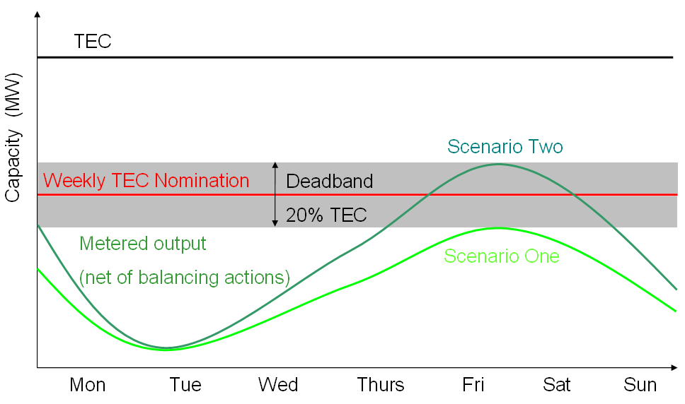

    - The proposer of WGAA1noted that to have a 10% deadband for both under and over-use would lead to a 20% band of error surrounding the Weekly TEC nomination. This is demonstrated in the above diagram. Therefore the dead-band would be 200MW for a 1000MW generator. A user could generate at any level between the maximum in scenario one and scenario two and avoid a charge. The proposer noted this would effectively take away the incentive to give up TEC envisaged by CAP168.

    - A majority of the Working Group did not support the Working Group Alternative Amendment raised by ConocoPhillips. Following a discussion at the CUSC Panel meeting on 3 April, 2009, the Working Group Chairman utilised the provisions set out in CUSC 8.17.15 to develop this Working Group Alternative Amendment despite a lack of support from the majority of the Working Group. This decision was taken due to the Working Group Chairman’s concern about the Proposer essentially losing control of the Amendment Proposal during the Working Group phase to the extent that the Proposer no longer believed that the Amendment Proposal met the original intent.

ASSESSMENT AGAINST APPLICABLE CUSC OBJECTIVES

  - The Working Group performed an assessment of CAP 168 Original against the Applicable the CUSC Objectives;

- the efficient discharge by the Licensee of the obligations imposed upon it by the act and the Transmission Licence; and

- facilitating effective competition in generation and supply of electricity and facilitating such competition in the sale, distribution and purchase of electricity.

The following table does not describe the agreed view of the entire Working Group but summarises views made by Working Group members for and against the proposal in terms of the Applicable CUSC Objectives.

Efficient discharge of licence conditions
Promotes | Demotes
Introduces a charge which is not based on cost reflectivity and could therefore be considered to be a penalty.

Introduces double charging for access.

Cost-reflective long-term and short-term access regimes should incentivise efficient TEC bookings. The introduction of arbitrary charges on long-term rights holders tips the balance and would cause inefficient outcomes in terms of TEC bookings and ultimately levels of transmission investment.

Power stations will be forced to run at full output to prove TEC requirement each year even if this is not the most efficient course of action (economically or environmentally).

Information forthcoming from weekly declarations are only another source of information for SO, over and above outage information provided under OC2 etc. It does not “free up” the equivalent amount of capacity. Benefits are overstated.

Deadband and running hours exemption will restrict additional capacity that can be released further. Latter provides incentive to keep hours below arbitrary limit of 500 hours.
Facilitates competition
Facilitates | Frustrates
Additional administration, including associated risk assessment required in making declarations, will demote competition. This will affect operators with lower numbers of plant more as they cannot benefit from economies of scale.

Creating timescales for capacity requirements will impact energy markets and could significantly reduce short term liquidity.

Proposal does not include sufficient investment certainty for new connections.

The proposal is only workable for those plants with predictable generation patterns.

May have implications for security of supply.

Arbitrary costs mean a penalty for those who cannot provide accurate estimate 5 weeks out. As this is arbitrary and not based on underlying costs caused or saved, it gives these parties an unfair competitive disadvantage.

Limited additional capacity will be released as for the reasons stated under licence obligations above. Therefore, it will not facilitate the trading of short term access in the manner suggested.

  - The Working Group performed an assessment of CAP 168 WGAA1 against the Applicable the CUSC Objective(s);

- the efficient discharge by the Licensee of the obligations imposed upon it by the act and the Transmission Licence; and

- facilitating effective competition in generation and supply of electricity and facilitating such competition in the sale, distribution and purchase of electricity.

The following table does not describe the agreed view of the entire Working Group but summarises views made by Working Group members for and against the proposal in terms of the Applicable CUSC Objectives.

Efficient discharge of licence conditions
Promotes | Demotes
Gives Users an extra incentive to release TEC which they do not require. | Introduces a charge which is not based on cost reflectivity and could therefore be considered to be a penalty.  Introduces double charging for access.  Cost-reflective long-term and short-term access regimes should incentivise efficient TEC bookings. The introduction of arbitrary charges on long-term rights holders tips the balance and would cause inefficient outcomes in terms of TEC bookings and ultimately levels of transmission investment.  Power stations will be forced to run at full output to prove TEC requirement each year even if this is not the most efficient course of action (economically or environmentally).  Information forthcoming from weekly declarations are only another source of information for SO, over and above outage information provided under OC2 etc. It does not “free up” the equivalent amount of capacity. Benefits are overstated.  Running hours exemption will restrict additional capacity that can be released further and provides incentive to keep hours below arbitrary limit of 500 hours.
Facilitates competition
Facilitates | Frustrates
Gives Users an extra incentive to release TEC which they do not require.  Facilitates the trading of short-term access.  Facilitates the connection of new Users. | Additional administration, including associated risk assessment required in making declarations, will demote competition. This will affect operators with lower numbers of plant more as they cannot benefit from economies of scale.  Creating timescales for capacity requirements will impact energy markets and could significantly reduce short term liquidity.  Proposal does not include sufficient investment certainty for new connections.  The proposal is only workable for those plants with predictable generation patterns.  May have implications for security of supply.  Arbitrary costs mean a penalty for those who cannot provide accurate estimate 5 weeks out. As this is arbitrary and not based on underlying costs caused or saved, it gives these parties an unfair competitive disadvantage.

7.0 PROPOSED IMPLEMENTATION

7.1 The Working Group propose CAP168 Original or WGAA1 should be implemented on the 1st April 2010 if an Authority decision in received by 1st December 2009 or 1st April 2011 if a decision is received after 1st December 2009 but before 1st December 2010. This is consistent with CAP161-CAP163. CAP168 only becomes fully effective when these are in place. IS changes would also be required to accommodate over usage and under usage. For the purposes of this report it has been assumed these would be completed in the same timescales as those for CAP161-CAP163. A more detailed assessment of this is underway.

8.0 IMPACT ON NATIONAL GRID IS SYSTEMS AND RESOURCES

8.1 Due to the Urgent timescales National Grid has not had time to perform a full assessment of the impact of CAP168 (Original and WGAA1) on IS systems and resource.

9.0 IMPACT ON THE CUSC

  - CAP168 (Original and WGAA1) requires amendments to Section 3, Section 5, Section 6 and Section 11 of the CUSC.

10.0 IMPACT ON INDUSTRY DOCUMENTS

Impact on Core Industry Documents

  - CAP168 (Original and WGAA1) has an impact upon the STC as a process for amending agreements will need to be developed.

  - CAP168 (Original and WGAA1) has an impact upon the Grid Code as the information exchange for CAP168 is operational and so should be submitted under the Grid Code.

Impact on other Industry Documents

  - It is envisaged the revenue flows should be passed through BSUoS. There may be changes required to a number of documents to facilitate this.

  - The charge for over and under-use will be contained in the charging statements.

11.0 WORKING GROUP VIEW / RECOMMENDATION

  - The Working Group has developed the Amendment Proposals (Original and WGAA1) to the extent possible given the Urgent timetable. Several substantial developments have been made to the Original Proposal through the discussions of the Working Group. However, the tight timescales have limited the ability of the Working Group to fully incorporate some aspects of the Originals Proposal, in particular two day ahead notifications.

  - The Working Group recommended to the CUSC Panel that:

- A Consultation Report containing the CAP168 Original Amendment and WGAA1 should proceed to wider Industry Consultation as soon as possible.
- The Working Group Report is accepted by the CUSC Panel and the Working Group is disbanded.

  - The Working Group voted on whether they believed the Amendment Proposals (Original and WGAA1) better, than the current baseline, facilitates the Applicable CUSC Objectives. The results of the vote are described in the following table:

Proposal | Better | Not better | Abstained
Original | 0 | 13 | 1
WGAA1 | 1 | 11 | 2

  - The Working Group voted on which version of CAP168 (Original and WGAA1) they believed best facilitates the Applicable CUSC Objectives. The results of the vote are described in the following table:

Proposal | Best
Original | 4
WGAA1 | 1
Abstained | 9

  - Four members of the Working Group voted that the Original was the best. It should be noted that these members also voted that the Original was not better than the baseline. One Working Group member voted that WGAA1 was best. This member also believed that WGAA1 was better than the baseline.

  - Nine Working Group members abstained. One of these Working Group members abstained as they would have another opportunity to vote as they were on the CUSC Panel. One member abstained as given the precedent set under CAP170 they were concerned that the Alternative (WGAA1) should not have been raised as an Urgent CUSC Amendment. One member pointed out that the Alternative (WGAA1) would potentially free up more capacity but puts more of a risk on generators. This member abstained as the balance of impact of these two aspects is difficult to assess at this stage. Some members abstained because they believed neither the Original nor the Alternative (WGAA1) better facilitated the CUSC Objectives.

12.0 NATIONAL GRID INITIAL VIEW

  - Creation of an additional charge will have a negative interaction with the efficient long run charge (based on incremental asset costs) and short run charges (based on incremental operational cost). Effectively this will adjust the balance of holdings to an inefficient level. This interaction will result in suboptimal decisions by network operators and generation companies, with the ultimate risks and costs borne by end consumers.

  - Considering the transportability of access we believe that most new developments will seek assurance in the form long term rights. We believe a functioning secondary market can provide an efficient counter to long term access, and can provide an efficient route to market for aging plant and a useful economic product for low load factor plant with a flat profile. However it is not desirable to force a secondary market, parties should chose to operate in the market based on the true costs and opportunities.

  - The proposal fails to address the divergence between the cost and the value of transmission on a constrained network. In order to encourage parties to release rights the incentive needs to be comparable to the value which users place on them. Furthermore under the current regime new parties would essentially be distressed buyers, with the potential for incumbents to extract value from transmission.

  - More accurate information available to the System Operator on the usage, rather than the availability (which is already a Grid Code and therefore licence requirement), would have additional value. However, we are not convinced that under the currently wholesale trading arrangements that it would be efficient for portfolio players to nominate which plant was likely to be operating several weeks in advance of gate closure. This will introduce additional risk and complexity and lead to the need for additional hedge arrangements. This issues was discussed the working group with general agreement that access release closure to real time would have much less value to either the system operator or new entrants.

  - Whilst the exchange of information and managing information imbalance risk may be a manageable for larger portfolio players, we believe the proposals introduces an inefficient burden on small parties and therefore could be considered discriminatory and a barrier to entry.

  - The application of an arbitrary charge with reference to a date whilst the normal energy market is still trading will create inefficiencies in the energy market. Whilst the date on which the charge is applied is logical, in relation to a proposed process in CAP161, this does not detract from its potential consequences on energy trading. This will create a disjoint in energy trading due to solely to this process and introduce additional risks in the wholesale market arrangements.

13.0 INDUSTRY VIEWS AND REPRESENTATIONS

  - Responses to the National Grid Pre-Consultation

    - Due to the period for Working Group development and assessment being shorter than usual the Working Group was unable to have a Working Group consultation. To ensure that the wider industry had the opportunity to provide input into the Working Group development and assessment National Grid conducted a pre-consultation on the Original Amendment Proposal as written. National Grid provided the responses to this pre-consultation to the Working Group for further consideration. A copy of the pre-consultation responses is available in Volume 2 of this report.

ANNEX 1 – CAP168 CUSC Amendment Proposal

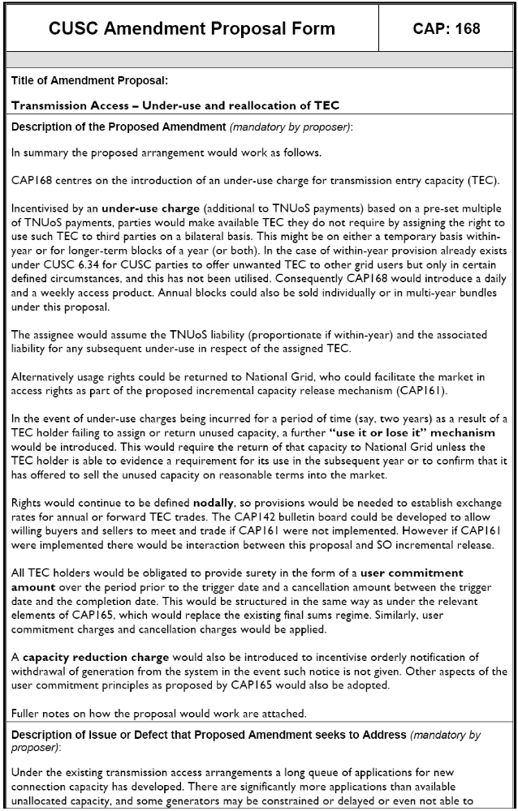
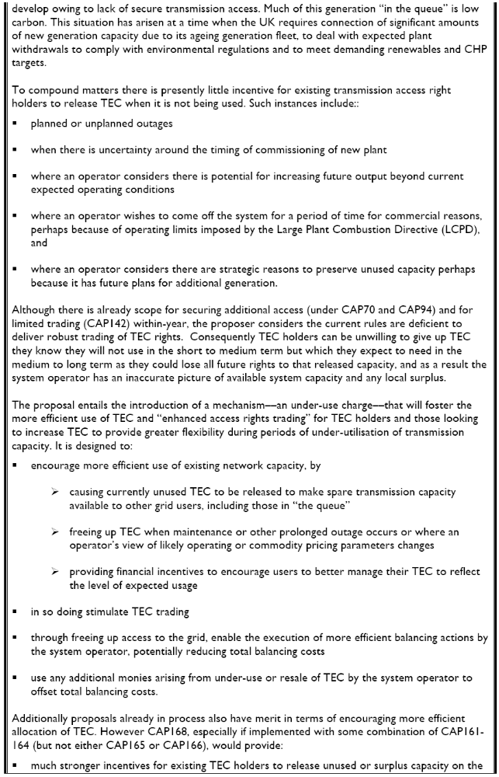
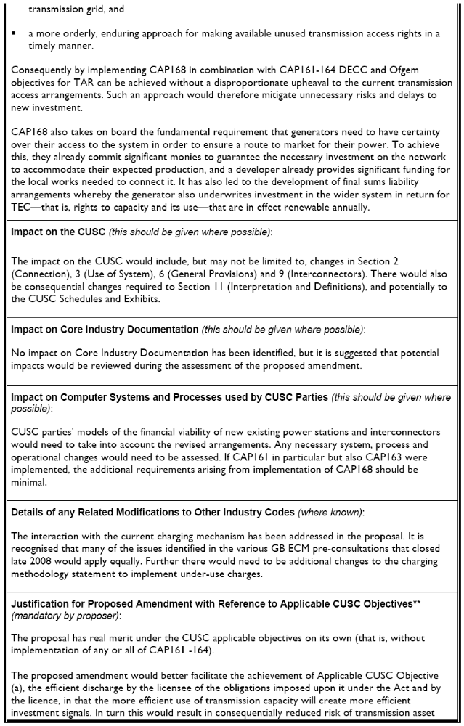

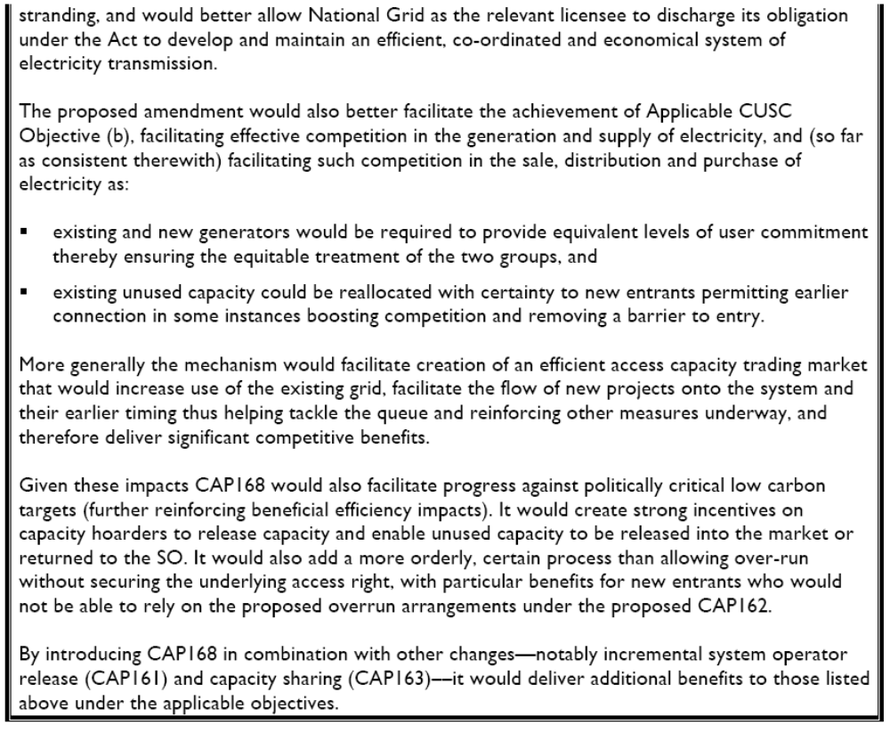

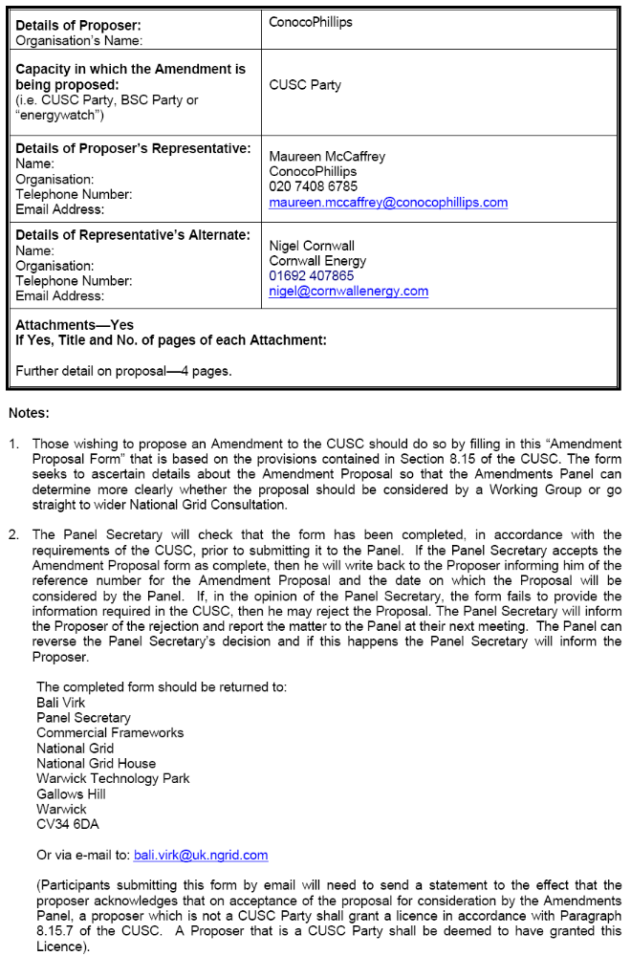

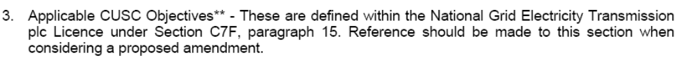

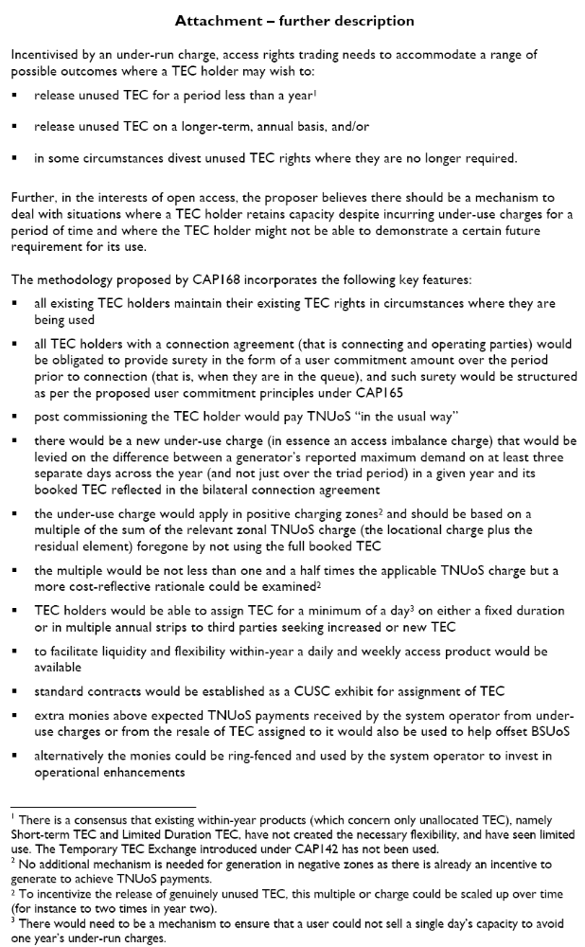

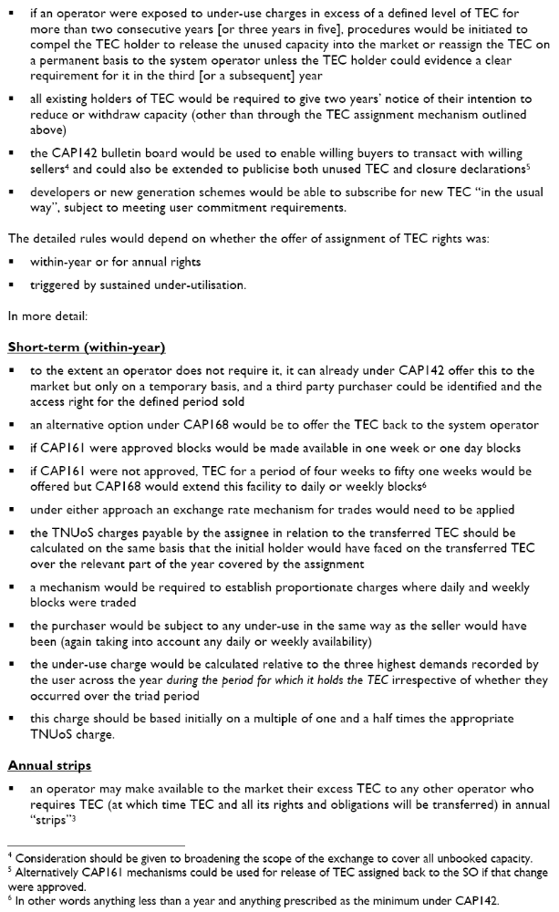

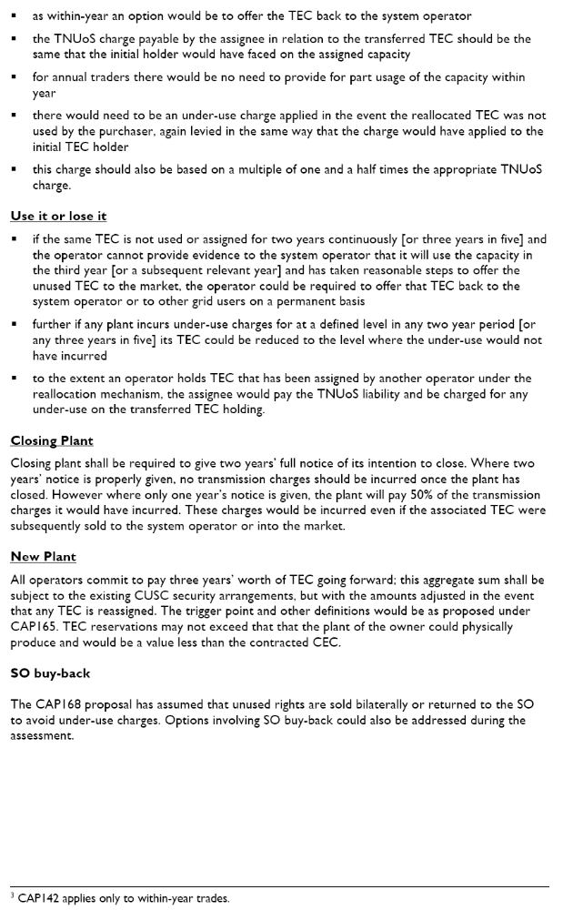

ANNEX 2 – CAP168 Working Group Terms of Reference

Working Group Terms of Reference and Membership

TERMS OF REFERENCE FOR CAP168 WORKING GROUP

Responsibilities

- The Working Group is responsible for assisting the CUSC Amendments Panel in the evaluation of CUSC Amendment Proposal CAP168 tabled by ConocoPhillips at the Amendments Panel meeting on the 27th February 2009.

- The proposal must be evaluated to consider whether it better facilitates achievement of the applicable CUSC objectives. These can be summarised as follows:

- the efficient discharge by the Licensee of the obligations imposed on it by the Act and the Transmission Licence; and

- facilitating effective competition in the generation and supply of electricity, and (so far as consistent therewith) facilitating such competition in the sale, distribution and purchase of electricity.

- It should be noted that additional provisions apply where it is proposed to modify the CUSC amendment provisions, and generally reference should be made to the Transmission Licence for the full definition of the term.

SCOPE OF WORK

- The Working Group must consider the issues raised by the Amendment Proposal and consider if the proposal identified better facilitates achievement of the Applicable CUSC Objectives.

- In addition to the overriding requirement of paragraph 4, the Working Group shall consider and report on the following specific issues:

-Introduction of an under-use charge for TEC
-TEC trading arrangements
-Facilitation of TEC trading
-Exchange rates
-Within-year trading
-Annual trading
-Process for offering TEC to SO
-“Use it or lose it” mechanism
-User commitment
-Capacity reduction charge
-Reserve
-Interaction with other proposals

- The Working Group is responsible for the formulation and evaluation of any Working Group Alternative Amendments (WGAAs) arising from Group discussions which would, as compared with the Amendment Proposal, better facilitate achieving the applicable CUSC objectives in relation to the issue or defect identified.

- The Working Group should become conversant with the definition of Working Group Alternative Amendments which appears in Section 11 (Interpretation and Definitions) of the CUSC. The definition entitles the Group and/or an individual Member of the Working Group to put forward a Working Group Alternative Amendment if the Member(s) genuinely believes the Alternative would better facilitate the achievement of the Applicable CUSC Objectives. The extent of the support for the Amendment Proposal or any Working Group Alternative Amendment arising from the Working Group’s discussions should be clearly described in the final Working Group Report to the CUSC Amendments Panel.

- There is an obligation on the Working Group Members to propose the minimum number of Working Group Alternatives where possible.

- All proposed Working Group Alternatives should include the proposer(s) details within the Final Working Group Report, for the avoidance of doubt this includes Alternative(s) which are proposed by the entire Working Group or subset of members.

- The Working Group is to submit their final report to the CUSC Panel Secretary on the 1st April 2009 for circulation to Panel Members. The conclusions will be presented to the CUSC Panel meeting on 3rd April 2009.

MEMBERSHIP

- It is recommended that the Working Group has the following members:

Chair Hêdd Roberts
National Grid Patrick Hynes
Industry Representatives James Anderson
Bob Brown
Michael Dodd
Richard Ford
Garth Graham
Paul Jones
Robert Longden
Simon Lord
Deborah MacPherson
Maureen McCaffrey
Rekha Patel
Bill Reed
Louise Schmitz
Merel van der Neut Kolfschoten
Barbara Vest
Charles Williams

Authority Representative Konrad Keyserlingk
Technical Secretary Sarah Hall

NB: Working Group must comprise at least 5 Members (who may be Panel Members)

- The Chair of the Working Group and the Chair of the CUSC Panel must agree a number that will be quorum for each Working Group meeting. The agreed figure for CAP168 is that at least 8 Working Group members must participate in a meeting for quorum to be met.

- A vote is to take place by all eligible Working Group members on the proposal and each Working Group Alternative, as appropriate, as to whether it better facilitates the CUSC Applicable Objectives and indicate which option is considered the BEST with regard to the CUSC Applicable Objectives. The results from the vote shall be recorded in the Working Group Report.

- Working Group Members or their appointed alternate is required to attend a minimum of 50% of the Working Group Meetings to be eligible to participate in the Working Group vote.

- The Technical Secretary is to keep an Attendance Record, for the Working Group meetings and to circulate the Attendance Record with the Action Notes after each meeting. This will be attached to the Final Working Report.

- The membership can be amended from time to time by the CUSC Amendments Panel.

RELATIONSHIP WITH AMENDMENTS PANEL

- The Working Group shall seek the views of the Amendments Panel before taking on any significant amount of work. In this event the Working Group Chairman should contact the CUSC Panel Secretary.

- The Working Group shall seek the Amendments Panel advice if a significant issue is raised during the Consultation process which would require a second period of Consultation in accordance with 8.17.17.

- Where the Working Group requires instruction, clarification or guidance from the Amendments Panel, particularly in relation to their Scope of Work, the Working Group Chairman should contact the CUSC Panel Secretary.

Meetings

- The Working Group shall, unless determined otherwise by the Amendments Panel, develop and adopt its own internal working procedures and provide a copy to the Panel Secretary for each of its Amendment Proposals.

Reporting

- The Working Group Chairman shall prepare a final report to the 3rd April 2009 Amendments Panel responding to the matter set out in the Terms of Reference.

- A draft Working Group Report must be circulated to Working Group members with not less than five business days given for comments.

- Any unresolved comments within the Working Group must be reflected in the final Working Group Report.

- The Chairman (or another member nominated by him) will present the Working Group report to the Amendments Panel as required.

ANNEX 3 – WORKING GROUP ATTENDANCE REGISTER

Name | 13/03/09 | 19/03/09 | 24/03/09
Hêdd Roberts | ✓ | ✓ | ✓
Sarah Hall | ✓ | ✓ | ✓
James Anderson | ✓ | ✓ | ✓
Bob Brown | ✓ | ✓ | ✓
Richard Ford | ✓ | ✗ | ✓
Garth Graham | ✓ | ✓ | ✓
Patrick Hynes | ✓ | ✓ | ✓
Paul Jones | Peter Bolitho | ✓ | ✓
Robert Longden | ✓ | ✓ | ✓
Simon Lord | ✓ | ✓ | ✗
Deborah MacPherson | ✗ | ✗ | ✗
Maureen McCaffrey | ✓ | ✓ | ✓
Rekha Patel | ✗ | ✓ | ✓
Bill Reed | ✓ | ✓ | ✓
Louise Schmitz | James Evans | ✓ | ✓
Merel van der Neut Kolfschoten | Dave Wilkerson | ✓ | ✗
Barbara Vest | ✓ | ✗ | ✗
Charles Williams | ✓ | ✗ | ✗
Observers | 13/03/09 | 19/03/09 | 24/03/09
Nigel Cornwall | ✓ | ✓ | ✗
Micheal Dodd | ✓ | ✗ | ✓
Ricky Hill | ✓ | ✗ | ✗
Konrad Keyserlingk | ✓ | ✓ | ✓
Paul Mott | ✓ | ✗ | ✗

ANNEX 4 – RESULT OF WORKING GROUP VOTE

The Working Group voted on whether they believed the CAP168 Amendment Proposals (Original and WGAA1) better, than the current baseline, facilitates the Applicable CUSC Objectives. The results of the vote are described in the following table:
Proposal | Better | Not better | Abstained
Original | 0 | 13 | 1
WGAA1 | 1 | 11 | 2

The Working Group voted on which version of CAP168 (Original and WGAA1) they believed best facilitates the Applicable CUSC Objectives. The results of this vote is described in the following table:

Proposal | Best
Original | 4
WGAA1 | 1
Abstained | 9

ANNEX 5 – ANALYSIS FROM NATIONAL GRID PRE-CONSULTATION
To aid the consideration of this amendment National Grid has provided some initial analysis to give an indication of the historic levels of capacity which could have been subject to an under-use charge.

This initial analysis compares the maximum metered output of each generator in a year with their booked TEC. The difference between the metered output and the TEC has been used to calculate the level of unused TEC for each generator. The used TEC of all generators has been summed together and the unused TEC of all generators has been summed together to give the following graph.

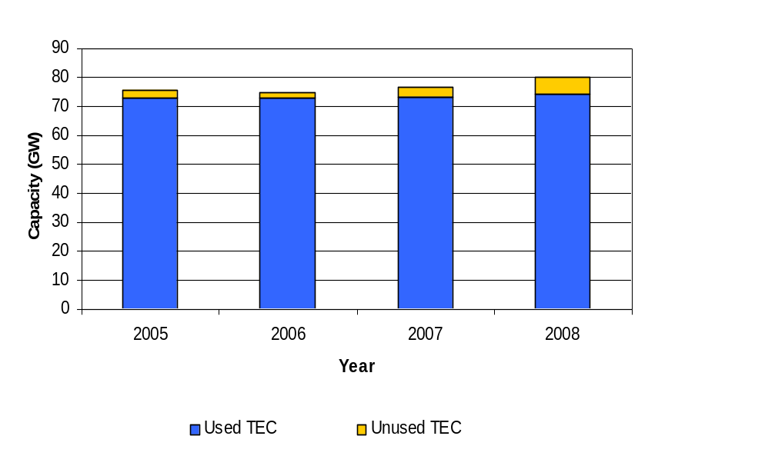

Capacity (GW) | 2005 | 2006 | 2007 | 2008
Unused TEC | 2.6 | 1.8 | 3.3 | 5.9
Used TEC | 70.3 | 71.1 | 70.0 | 68.4
Total TEC | 72.9 | 72.9 | 73.3 | 74.3

This analysis shows that in previous years between 1.8 and 5.9 GW could potentially have been charged for under-use if no action was taken to release this capacity to other users. The proposal suggests using the three maximum outputs. Using three maximum outputs would potentially make more capacity chargeable under the new arrangements.

The following graph shows the amount of unused TEC since 2005 in GW. The information is split into three categories. The Scotland category includes those generators currently in TNUoS tariff zones one to eight. England and Wales has been split to show how much of the unused TEC is in TNUoS tariff zones with a negative tariff and how much is in positive zones.
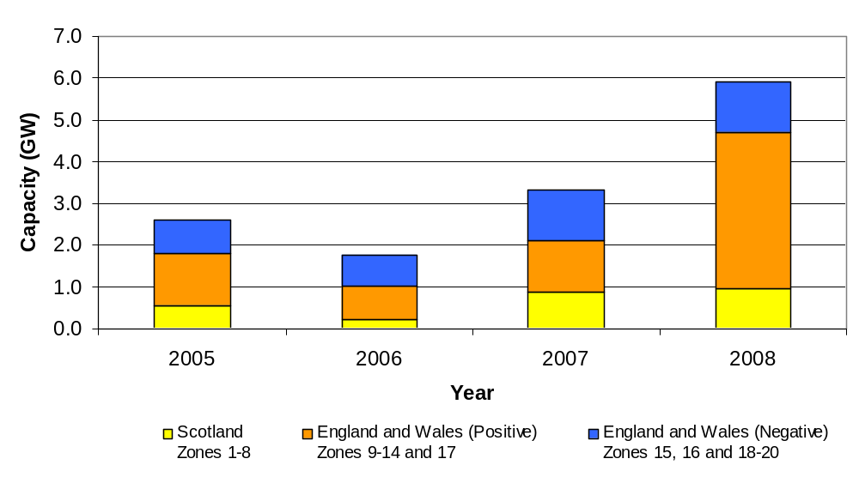

Capacity (GW) | Zones | 2005 | 2006 | 2007 | 2008
Scotland | 1-8 | 0.6 | 0.2 | 0.9 | 0.9
England and Wales (Positive) | 9-14, 17 | 1.2 | 0.8 | 1.2 | 3.8*
England and Wales (Negative) | 15,16, 18-20 | 0.8 | 0.8 | 1.2 | 1.2
*The trebling in unused TEC between 2007 and 2008 in positive zones in England a Wales is due to two large generators being on outage during 2008.

The majority of unused TEC is in positive zones in England and Wales as this is where the majority of generation is situated. The unused TEC is approximately 3% on average of the total TEC in positive zones in England and Wales. Although less TEC is unused in Scotland and the negative zones in England and Wales a greater percentage of TEC is unused. In Scotland 11% of TEC is unused and 10% is unused in negative zones in England and Wales.

ANNEX 6 – FURTHER ANALYSIS

Consistent Under-use
At the CAP168 Working Group meeting on the 13th March 2009 National Grid took an action to analyse how much TEC was consistently not being used.

Data from 88 generators between January 2005 and February 2009 was reviewed. The amount of TEC which had consistently not been used during this period was approximately 1.25 GW. This is calculated by looking at the difference between the maximum metered output of each generator since January 2005 and their booked TEC. The following graphs show how this is distributed zonally and by plant type.

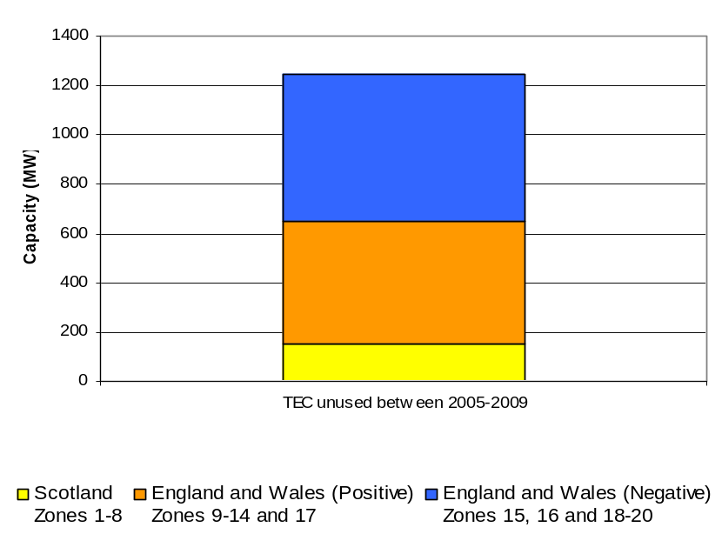

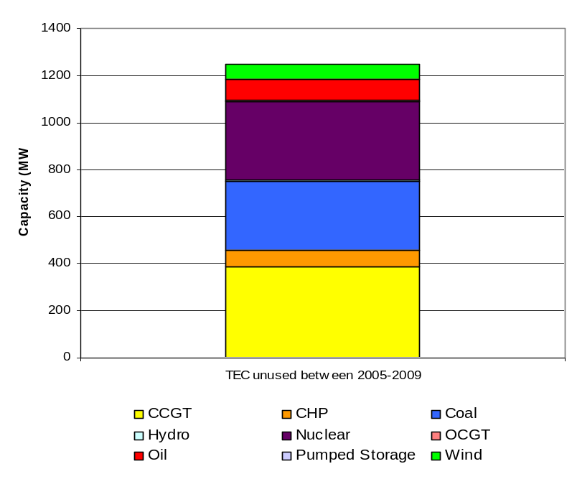

Under-use Capacity
It was suggested at Friday’s Working Group meeting that considering a Users output on three days may not be a severe enough test to measure the capacity which the under-use charge should be levied upon. The following analysis looks at the maximum, the third greatest daily output to the 80th greatest daily output. In 2008 the difference between TEC and the X greatest daily output was:

X | 1 | 3 | 10 | 20 | 40 | 80
Difference (GW) | 5.9 | 6.7 | 7.8 | 8.7 | 10.5 | 14.3

The following graph shows the percentage of TEC in Users’ bilateral agreements not used during the maximum output, the third greatest daily output, the 10th greatest daily output and the 20th greatest daily output by different plant types.

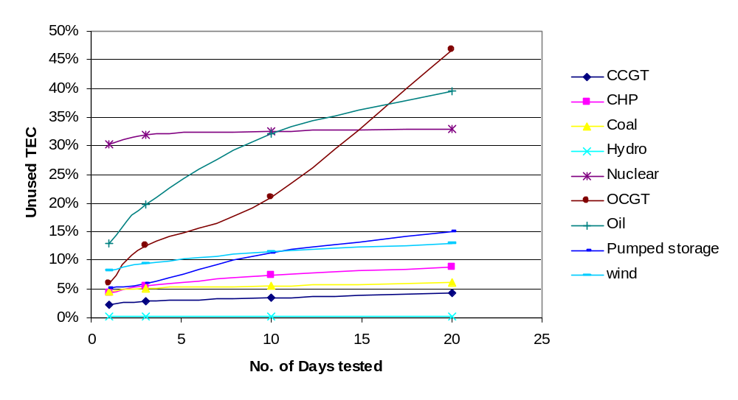
An additional two data points were measured at 40 an 80 to provide the group with further information.
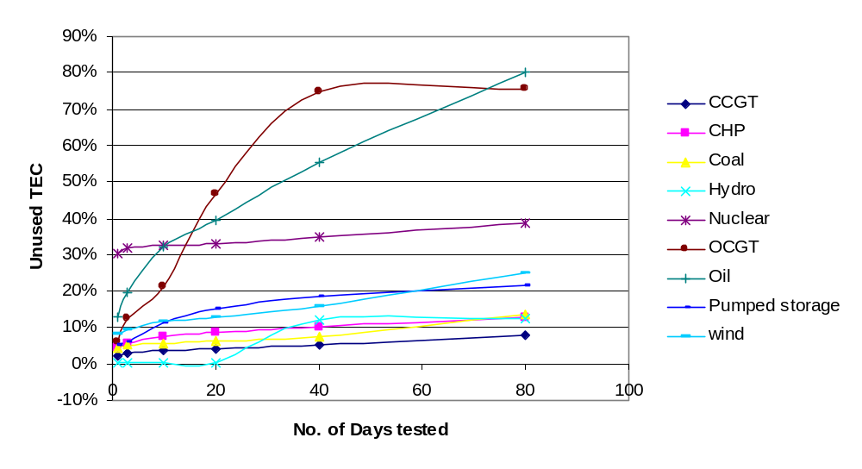

This graph shows data from 2008. During this year two nuclear plants had outages. This has bought the average up for nuclear plants.
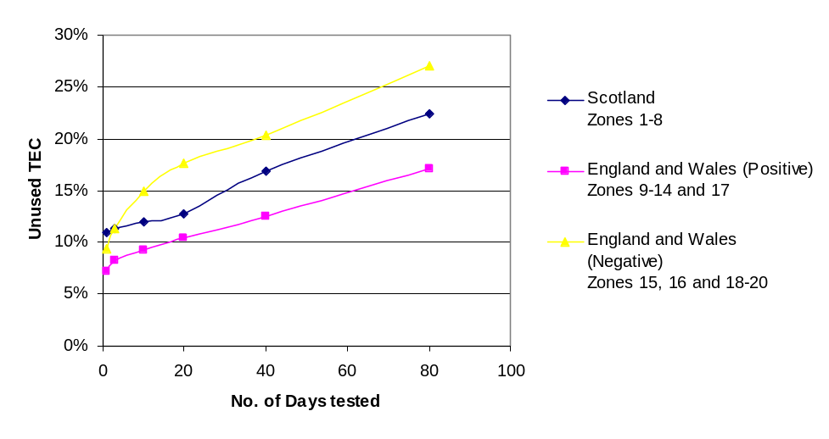
After seeing the first draft of this analysis a further request was made to see the level of money which would have been recovered had an under-use charge of 1.5 x TNUoS been in place.

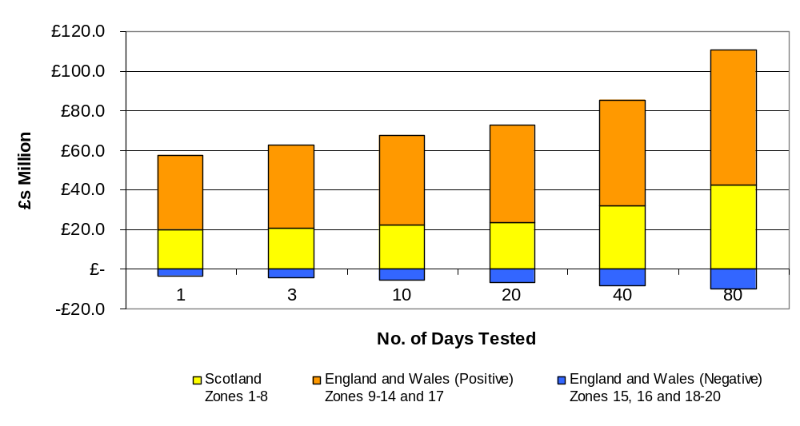

ANNEX 7 – FURTHER DETAILS OF USER COMMITMENT

Pre-Comissioning User Commitment
The CAP168 proposed arrangements for pre-commissioning generators (and for post-commissioning generators that request additional wider entry access rights) requiring transmission works seek to replace the current liabilities for cost reflective final sums with non-refundable generic liabilities. An aim would also be to share the risk of inefficient investment associated with generation termination between the generators that introduce risk, and all other Users.

The generic liabilities incurred would be a non-refundable termination charge equal to three times the relevant generation TNUoS tariff. Under CAP168, this multiplier would set not just the termination liability pre-commissioning but also the minimum number of years of wider entry access rights to the transmission system that a newly commissioned User would be liable for. Therefore, under CAP168 the potential termination liability immediately prior to commissioning and immediately post commissioning would be equivalent (at three years’ worth of TNUoS). Further details regarding the post commissioning User commitment are considered later in this annex.

These arrangements would only apply to wider transmission entry access rights. Separate, but similar, arrangements would apply to infrastructure comprising generators’ local connections to the wider system. Additionally, for parties not booking entry access rights (e.g. DNOs), the current cost reflective final sums arrangements will continued to be applied for transmission reinforcement works.

The offer will set out two types of payments that would be due in the event of termination: User Commitment Amounts before the Trigger Date, and Cancellation Amounts between the Trigger Date and the Completion Date. The process is illustrated in the diagram below:
Calculation of timescales for pre-commissioning termination payments

£
m
Offer
Completion Date
Trigger Date
t/y
User Commitment
Amount
Cancellation Amount
STEP 1
Count back in project
years from Completion Date
(Max. 4 years)
STEP 2
Count forward in
years
until Trigger Date
(if applicable)

It can be expected that following the Trigger Date, the majority of applications for new or increased wider entry access rights will result in a Completion Date within four years. It should be noted that under the CAP168 arrangements, National Grid will retain the right in the Construction Agreement to delay the Completion Date owing to unforeseen circumstances beyond its control.

User Commitment Charge
Between the Offer Date and Trigger Date, termination of wider transmission entry access rights requested would result in the levying of a User Commitment Charge based on User Commitment Amounts. The User Commitment Charge will be non-refundable.

User Commitment Amounts would be calculated using a generic methodology, based on a value of £1/kW commencing upon signature of the Construction Agreement. This would increase by £1/kW following each full year up to the Trigger Date, subject to a cap of £3/kW. Should a User terminate its Construction Agreement prior to the Trigger Date the User‘s User Commitment Charge would therefore be calculated as follows:

User Commitment Charge = TEC_{r} x UCAM_{t}

Where:

- TEC is the reduction in wider entry access rights in kW.
- UCAM_{t} is the relevant User Commitment Amount which varies according to the number of full years from the Offer Date:
  - In the first year (i.e. t =1) UCAM_{t} = Min (£1/kW, TA x 25%), where TA is the Termination Amount (see below);
  - Where t = 2, UCAM_{t} = Min (£2/kW, TA x 25%); and
  - Where t ≥ 3, UCAM_{t} = Min (£3/kW, TA x 25%).

In negative TNUoS charging zones or zones with marginally positive charges 25% of the Termination Amount described below will be less than £3/kW. In such zones User Commitment Amounts would be capped to 25% of the Termination Amount. This would lead to User Commitment Amounts being zero in negative charging zones.

User Commitment Amounts where they are calculated by reference to TNUoS tariffs will be calculated and fixed at the time the connection offer is signed. The actual TNUoS tariff used will be that TNUoS tariff that would have prevailed on the last day that that offer could have been signed.

Cancellation Charges
Under CAP168 once the Trigger Date has been reached, termination of wider transmission entry access rights requested would result in the levying of a Cancellation Charge based on Cancellation Amounts. The Cancellation Charge will be non-refundable.

The Cancellation Amount in each year is a percentage of the Termination Amount, which is the higher of zero and three times the relevant TNUoS charges. The Cancellation Charge would therefore be calculated as follows:

Cancellation Charge = TEC_{r} x CAM_{t}

Where:

- TEC_{r} is the reduction in wider transmission entry access rights in kW.
- CAM_{t} is the relevant Cancellation Amount which varies according to the number of full years from the Completion Date:
  - In the year prior to the Completion Date (i.e. t) CAM = TA x 100%), where TA is the Termination Amount;
  - Where t=-1, CAM = TA x 75%;
  - Where t=-2, CAM = TA x 50%; and
  - Where t=-3, CAM = TA x 25%.

Termination Amount = Max (0, (GenTNUoS_{z} x X))

Where:

- GenTNUoS_{z} is the relevant zonal Generation TNUoS tariff calculated and fixed at the time the connection offer is signed. The actual TNUoS tariff used will be that TNUoS tariff that would have prevailed on the last day that that offer could have been signed. If a project is not located in a Generation TNUoS Charging Zone, then the appropriate Generation TNUoS tariff will be calculated by National Grid as part of the application process in accordance with the Charging Methodology.
- X is a multiplier, initially taking the value three, although it may be appropriate that this be amended in subsequent transmission price control periods.

The liabilities described above can be summarised in the diagram below:

Generic capacity reduction Liabilities for new or increased wider entry access rights

t

£
Offer
Signature
Completion
Date
Trigger
Date
At “t” Cancellation Amount =
Termination Amount x 100% =
3 x Generation TNUoS tariff

t-1

t-2

t-3

t
25%
50%
75%
100%
User Commitment Amount
Amount
Cancellation Amount
£1/kW
£2/kW
Max
£3/kW
Subject to a maximum of Termination Amount x 25%

Charges based on User Commitment Amounts and Cancellation Amounts would not apply to projects where there are no transmission asset works.

Capacity Reduction Charges
In addition to the above charges applicable at termination of a User’s Construction Agreement, Capacity Reduction Charges will also become liable if the User reduces its wider transmission access rights prior to the Completion Date or Trigger Date.

Should a User reduce its wider transmission access rights prior to the Trigger Date it shall become liable to pay the following Capacity Reduction Charge:

Capacity Reduction Charge = UCAM_{t} × (TEC – TEC_{r})

- Where the UCAM is calculated in accordance with 3.16 above;
- TEC is the TEC figure (expressed in kW) stated in Appendix C to the Users Bilateral Agreement effective immediately prior to the requested reduction in TEC; and,
- TEC_{r} is the revised TEC figure (expressed in kW) following the TEC reduction

Should a User reduce its wider transmission access rights on or after the Trigger Date but before the Completion Date it shall become liable to pay the following Capacity Reduction Charge:

Capacity Reduction Charge = CAM_{t} × (TEC – TEC_{r})

- Where CAM_{t} is calculated in accordance with paragraph
- TEC is the TEC figure (expressed in kW) stated in Appendix C to the Users Bilateral Connection Agreement or effective immediately prior to the requested reduction in TEC
- TEC_{r} is the revised TEC figure (expressed in kW) following the TEC reduction

Security
The introduction of generic User Commitment Charges and Cancellation Charges defined in the CUSC, to replace the existing final sums regime defined in Construction Agreements, will also require the introduction of provisions to define the level of financial security that should be held in relation to these potential liabilities.

CAP168 proposes move the security arrangements from Construction Agreements and to instead add the applicable User Commitment Charges or Cancellation Charges to each User’s Security Requirement,. To the extent that these amounts exceed the Allowed Credit extended to each User, Security Cover will need to be provided to National Grid, in any of the forms prescribed in the CUSC.

In the event a Capacity Reduction Charge becomes payable, the amounts secured in respect of the User Commitment Charge or Cancellation Charge will be re-calculated by reference to the new TEC level, post-reduction.

Transition
If CAP168 is approved, existing Users will have the choice to remain in their existing security and liability arrangements or to move across onto the new CAP168 arrangements. Users applying for a new connection or an increase in wider transmission access rights post any implementation of CAP168 will be subject to the CAP168 arrangements.

Should existing Users choose to migrate to the new CAP168 arrangements this will require a Trigger Date to be set, and the calculation of User Commitment Charges or Cancellation Charges (as applicable), for all pre-commissioning projects in progress at implementation. The security required for each User will be calculated in accordance with the revised Section 3 of CUSC, and therefore additional Security Cover may be required. Equally, in situations where less cover is required, security will be returned to Users.

Changes to the Trigger Date or Completion Date – Impact on Pre-Commissioning Liabilities
Where the Construction Programme or the Construction Works or Transmission Entry Capacity subsequently change from that in the original Construction Agreement the following principles will apply in respect of reassessing the Trigger Date and the Cancellation Charge.

Where such change is as a result of The Company’s exercise of its rights under the Construction Agreement then:

Where there is a delay to the Completion Date, and the Trigger Date has not passed there will be a corresponding delay to the Trigger Date and the profile of the User Commitment Amount and the Cancellation Amount revised accordingly in line with the above principles. If the Trigger Date has already passed, the profile of the Cancellation Amount will be revised accordingly on the basis of the above principles by reference to the number of full 12-month periods from the new Completion Date.

Where there is no delay to the Completion Date, but the Construction Works change, The Company will review the appropriateness of the Trigger Date and if appropriate, change this. The profile of the User Commitment Amount and Cancellation Amount will be revised on the principles set out above to reflect the change in Trigger Date.

Where there is a reduction in a User’s Transmission Entry Capacity the Cancellation Charge shall be revised to reflect the reduced MWs.

A revised Appendix R to a User’s Construction Agreement will be issued by The Company to the User showing the new profile.

Where such change is as a result of the User’s request a revised Appendix R to a User’s Construction Agreement will be issued by the Company to the User. Notwithstanding any change in the Construction Works or Completion Date:

Where the revised Construction Programme alters the period of full years between the date of signature of the original Construction Agreement and the Trigger Date the User Commitment Amount will remain at the amount at the time the user requested the change until it is due to rise based on the revised Appendix R reflecting the revised Construction Programme; or

The Cancellation Amount will be frozen at the prevailing level and remain at that level for the period of the slippage.

Post-commissioning User Commitment
It is proposed, under CAP168, that new Users would be liable for three years worth of TNUoS charges. Under CAP168, post-commissioning User commitment would be given by a liability to pay TNUoS for a Commitment Period. This commitment period would be two years.

By the 31 March (or prior working day if this falls on a non-working day each year, each generator would have to decide whether to:

- Remain on the system for another two years
  - No action would be required by the generator
  - National Grid would receive TNUoS for the generator for at least the following two years
  - National Grid would have a signal that further investment is viable in the applicable area; or

- Decide to leave the system after the next two years
- The generator would submit a “Commitment Notice”
- National Grid would receive TNUoS from the generator each year for the next two years only
- The generator would leave the system at the end of the two years. For clarity, an example would be:
  - Generator submits a Commitment Notice on 31 March 2011
  - Generator does not have the option to remain on the system beyond the second year of the notice period (31st March 2013), unless they successfully reapply for new TEC capacity
- At the end of the Notice period, the generator would relinquish their wider transmission access rights and would have to reapply (just as a new User would) for wider transmission access rights in the future. For the avoidance of doubt the generator would reapply at any point up to (and beyond) the two year notice period. In the example they could reapply from the 1st April 2011 for wider transmission access up and matching (but not exceeding) their LCN.

A generator could choose to relinquish their long term wider transmission access rights early at any time. However, the generator would have to pay National Grid the greater of:

- Any outstanding commitment for the current year, plus either:
  - If no Commitment Notice has been received, the relevant commitment for the next two years
  - If a Commitment Notice has been received, the relevant commitment for the remainder of the notice period; or

- Zero

A generator relinquishing their wider transmission access rights would have to reapply for a connection if they wish to obtain such rights in the future.
- They can only rejoin if there is capacity available
- All Users wishing to obtain wider transmission access rights will have equal priority (as between new Users and previous Users)

ANNEX 8 – LEGAL TEXT TO SUPPORT THE PROPOSAL

