Hotspots Report

September 2018

Add date here

Hotspots

## Energy costs

Energy costs (including energy imbalance) for September 2018 out-turned at around £38m, with an increase from the previous month outturn of £1.3m. The average daily energy spend for this month was around £1.3m. The energy costs increase from the previous month, was mainly due to an energy imbalance being £3.3m higher. Operating Reserve and Frequency Response were the only energy costs that increased from the previous month, with an increase in both cases of around £1.0m. Fast Reserve, and STOR decreased of around £1.5m and £1.0m, respectively. All the others categories showed little variance.



## Energy total daily outturn



Daily energy costs remained below or around £1.0m over the first half of September 2018. Afterwards there were a number of days when the daily spend was over £1.5m, and peaked at around £2.5m on Wednesday 19th, Thursday 20th, and Saturday 22nd. The Energy Imbalance was the main drive behind these high costs days which were characterized by long periods of short market, throughout the 24 hours, sometimes in excess of over 2GW. Another high spend day was Wednesday 26th, when periods of short market in excess of 1.6GW combined with high volume of STOR deployed following generating plants losses, were the main drives behind a daily cost of around £2.2m.

## Operating Reserve

Operating Reserve out-turned at £5.6m showing an increase from August 2018 of around £1.0m. The highest daily cost for this category was recorded on Wednesday 19th, with spend of circa £0.5m.

On that day, the market was short in excess of 1.2GW overnight and in excess of 2.6GW during the morning and the afternoon. In addition, adverse weather conditions and high wind levels, triggered constraints that prevented the access to generation that was in merit to provide reserve margin, bringing up the constraint margin costs to around £0.4m.

Overall, constraint margin cost for September 2018 accounted for over 70% of the monthly spend.



## STOR

STOR cost for September 2018 was £5.7m which is £1.0m lower than the past month. The average STOR daily cost was £0.2m. However, costs above £0.3m were recorded on some days. On Tuesday 11th, up to 900MW of STOR was utilised due to interconnector and generator physical notification changes. On Wednesday 12th, up to 660MW of STOR was deployed to account for wind shortfalls against forecast and around 300MW was used during the evening peak. On Saturday 22nd, STOR in excess of 700MW was utilised in the morning and in excess of 150MW in the evening due to the demand outturning higher than forecast.



## Margin Price

The Average margin price in September 2018 decreased from the past month out-turning at £21.84/MWh.



## Frequency Response

Frequency response in September 2018 out turned at £11.3m showing an increase from last month of £0.8m. Around 80% of the monthly cost were ancillary costs with the remaining incurred in the BM, positioning units to provide a response service. The average daily cost was just below £0.4m. Tuesday 11th was the most expensive day for this category with a spend of around £0.7m. On that day, there were operational risks that required additional response and reserve levels to be held for risk mitigation, and SpinGen service to be utilised. A similar daily cost figure incurred on Wednesday 26th, when additional dynamic high response was held between midnight and the late morning to account for wind volatility.



## Fast Reserve

Fast reserve out turned at £7.0m, which is £1.5m lower than August 2018 costs. Throughout the month, the average daily cost was around £0.2m and the ancillary costs made up circa 86% of the total costs, most of which is incurred on the SpinGen service. Arming the service delivers consumer value over procuring reserve in the balancing mechanism as Operating Reserve.



## Negative Reserve

Negative Reserve out-turned at £0.4m, showing no variance from the past month. The costs for this category were nil or below £0.1k for most of the days in September 2018.



# 

# Constraints Costs

The total constraints cost for September 2018 was £101.9m; £43.5m for England and Wales, £14.9m for Cheviot, £3.4m for Scotland, £22.0m for Sterilised Headroom, £16.9m on RoCoF, and £1.3m on Ancillary Services costs.

The graph above shows the daily outturn costs and the proportion made up by RoCoF. It also shows output levels of balancing mechanism (BM) wind and volume of wind bids (including trades) to indicate the extent to which wind output drives constraint costs. From the second week of September, the combination of key planned outages and the unavailability of the Western HVDC Link interconnector, triggered high volume of wind bids especially on days with adverse weather conditions and high wind levels, keeping the constraint costs high on most of the days. The highest costs were recorded on Wednesday 19th, and Saturday 29th and Sunday 30th with a spend of around £8.6m, £8.0m and £8.9m respectively. In all cases, the power flow restrictions that were in place due to planned outages, were exacerbated by the sustained high wind levels in Scotland, Wales and England. Large volumes of wind generation was bought off in the BM and with trades actions to solve constraints on the network boundary between England and Scotland. Similar scenarios were repeated on many other days in September, bringing the daily costs in excess of £5m in many cases.

## RoCoF

The RoCoF outturn for September 2018 was £16.9m, which is £3.4m higher than costs recorded in the previous month. Wind and demand levels are the main driver behind high costs days for this category, requiring large volumes of trades on the interconnectors and on generating units, sometimes with the support of BM actions, to limit the largest generation loss on the system. The highest daily cost for this category incurred on Sunday 9th, with a spend of around £1.6m. A day characterised by low demand, and wind generation level uncertainty together with the loss of inertia contribution from one generator, caused the high spend. Another high cost day was Sunday 23rd when the daily spend peaked at £1.4m.

## Voltage

These costs relate to the buying of energy, in order to access the voltage capability on the generating units. The costs for voltage are reported in the Reactive Power category. Voltage costs in September 2018 out-turned at around £2.2m to deliver 237.9GWh of energy with voltage supporting capabilities, of which around 60% of volumes were solved with forward trading.

On the 18th September six different generating units were bought on to cover four different regions. High wind output overnight meant lack of self-despatching plant, hence the requirement to bring units on.

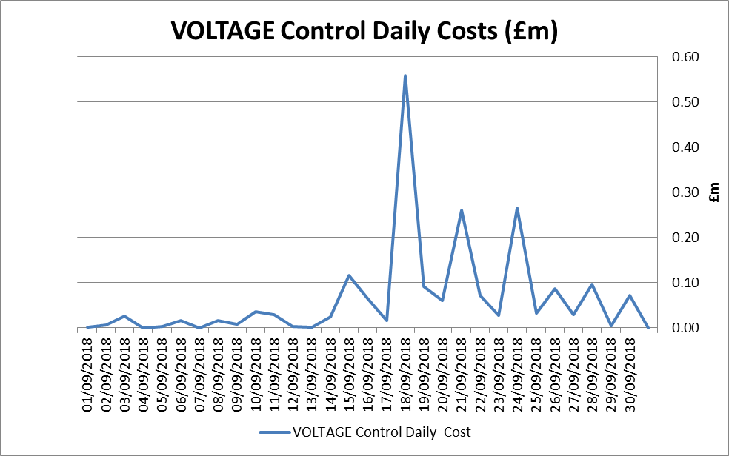



nationalgrideso.com

Faraday House, Warwick Technology Park,  
Gallows Hill, Warwick, CV346DA